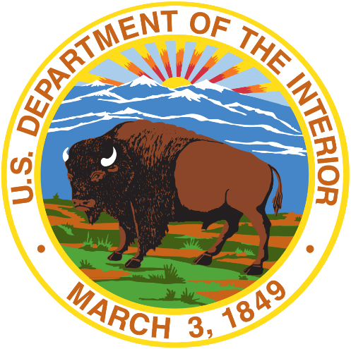

U.S. Department of the Interior

Office of Policy Analysis Seminar Series

**“3 for 3 for the WIN”: Taking strategic invasive species action at the Department of the Interior to advance 3 national invasive species initiatives in 3 years**

2024-11-17, 2:00-3:15pm ET, Microsoft Town Hall

# Lecturer with solid fillSpeakers

**Stas Burgiel**, Executive Director, National Invasive Species Council

**Earl Campbell**, Field Supervisor, Pacific Islands Fish and Wildlife Office, USFWS

**Mark Frey**, Coordinator, National Early Detection and Rapid Response Framework, DOI

**Hilary Smith**, Senior Advisor for Invasive Species, DOI

**Mike Zupco**, Executive Director, Wildland Fire Leadership Council

# Monthly calendar with solid fillWhen

 Tuesday, 17 December 2024, 2:00 – 3:15pm Eastern

# Where

 [Click here to join](https://teams.microsoft.com/l/meetup-join/19%3ameeting_ZTllOGNiNjMtZWFmOS00MjA1LTg1MjQtNjYyNGIzYTMxZTUz%40thread.v2/0?context=%7b%22Tid%22%3a%220693b5ba-4b18-4d7b-9341-f32f400a5494%22%2c%22Oid%22%3a%22b9ef6aad-d96f-430b-a410-2a029d49b087%22%7d) Microsoft Town Hall

# Accessibility

Closed captioning is available; subtitles in English and Spanish will be available.

# Document with solid fillSummary

# Invasive species harm the American way of life. Invasive plants, animals, and pathogens can damage our food supply; fuel devastating wildfires; degrade recreational pastimes like hunting, fishing, and boating; lead to native species extinctions; and put human health at risk, among other adverse impacts. Once established, invasive species infestations can be extremely difficult and costly to control. Economic impacts are estimated to be in the billions nationwide. Because of this, people may think that invasive species management is too challenging, too overwhelming, and hopeless. But, through collaboration, strategic action, and innovation, progress can be made in turning the tide on invasive species. The Department of the Interior plays a central role in the stewardship of public lands. This seminar will highlight three signature Departmental initiatives led in collaboration with partners to tackle some of the most urgent invasive species issues: (W)ildfire and Invasive species, (I)slands and Invasive Species, and a (N)ational Early Detection and Rapid Response Framework. The presentation will feature examples of accomplishments through each of these initiatives. This includes working with agencies and partners to: minimize wildfire risk through targeted invasive species management; address the conservation crisis faced by Hawaiian forest birds due to avian malaria; and mobilize resources to combat newly arriving invasive species before they establish, spread, and cause harm.

# Information with solid fillFor more information

For more information on the Seminar, please contact the Office of Policy Analysis, [ppa@ios.doi.gov](mailto:ppa@ios.doi.gov).

Text Box