Interior’s Office of Policy Analysis Seminar
Tourism in Indian Country

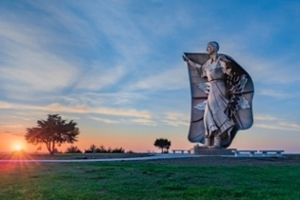
Dignity statue, Chamberlain, South Dakota
Courtesy of South Dakota Department of Tourism

Speakers:
Edward Hall, Project Manager, Bureau of Trust Fund Administration and former Tourism Coordinator, Bureau of Indian Affairs (BIA)
Seleni Matus, Executive Director, International Institute of Tourism Studies, The George Washington University
Topic: Tourism in Indian Country
Date: Monday, August 9, 2021
Time: 12:15-1:15 PM (Eastern)

Webcast Only: Microsoft Teams Live Event (This link also accesses the recorded video after the event)
Closed captioning (CC) is available.

Tourism can provide Indian Country with significant economic benefits while offering an avenue to reclaim, maintain, shape and share traditions and narratives. Tourism in Indian Country can also respond to visitor interest in rewarding and authentic cultural experiences. The Departments of Commerce and Interior are leading the effort to implement the NATIVE Act, which mandates Federal agencies to identify and coordinate existing programs and resources that support tribal capacity building for tourism development. Ed Hall helped to create the first Indigenous Tourism Forum of the America’s with the George Washington University and the Organization of American States. For more information, go to: https://indigenoustourismforum.org/

To view the Live Event, please click on the link above. Join 5-10 minutes early to avoid technical difficulties.

The public is welcome to join the Microsoft Live (or recorded) event.

For Interior Department Registrants Only: This seminar meets one hour of Executive Education training. To document your attendance, register via DOI Talent. Be sure to return to DOI Talent to mark yourself complete after you have attended the seminar.

For additional information about this event, please contact Malka Pattison at: malka_pattison@ios.doi.gov

