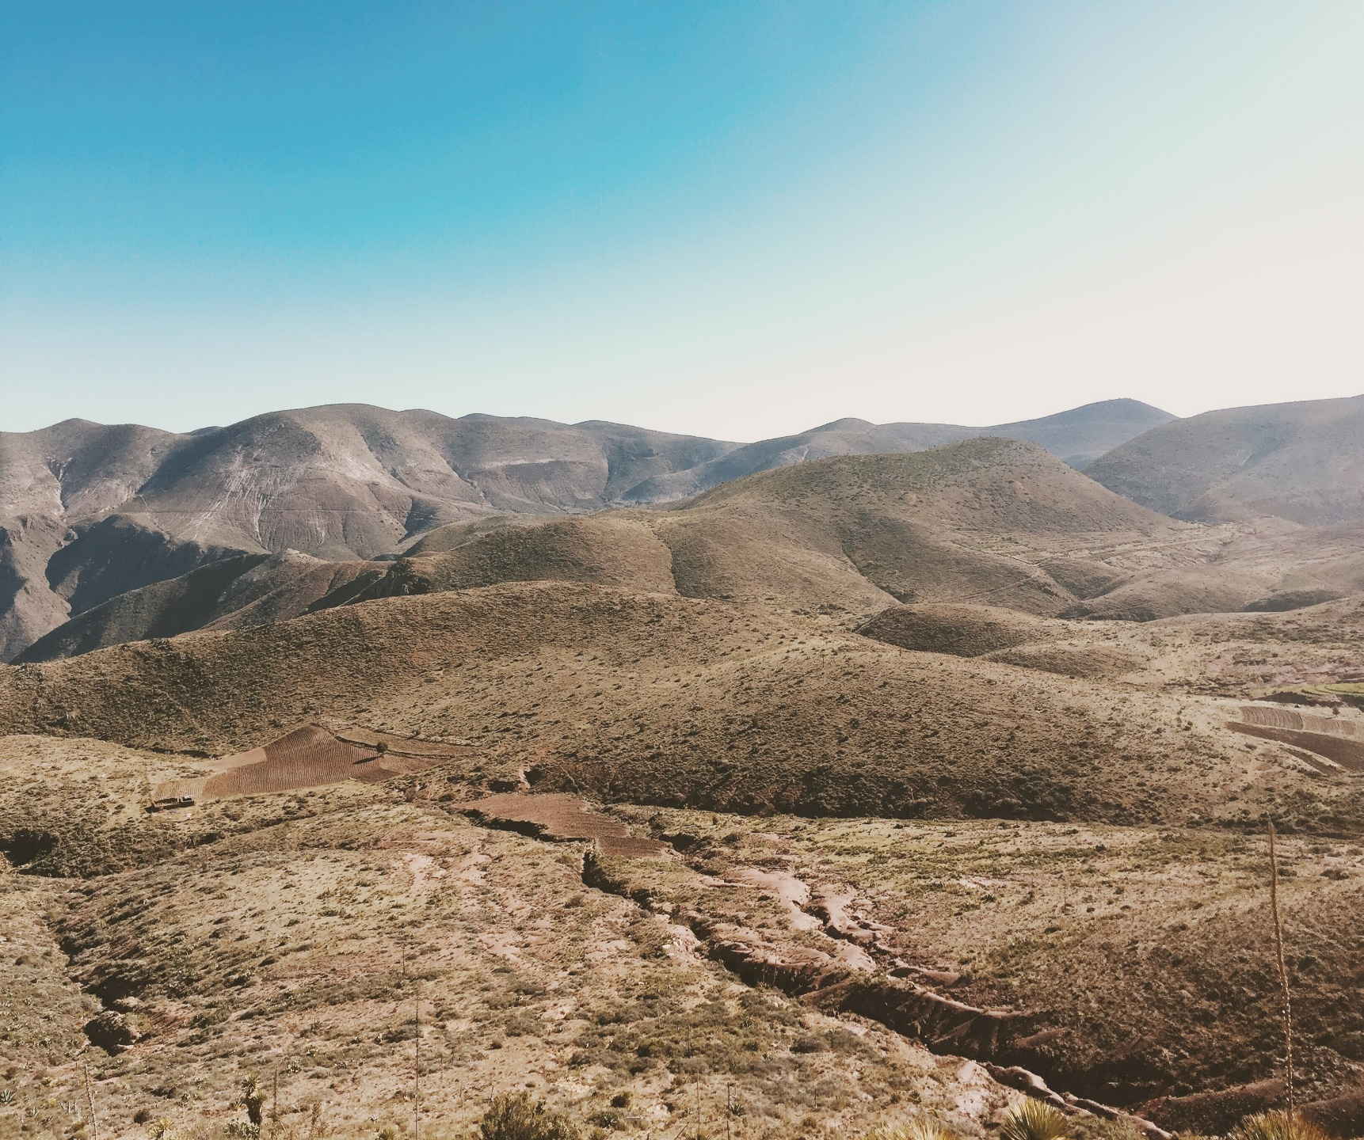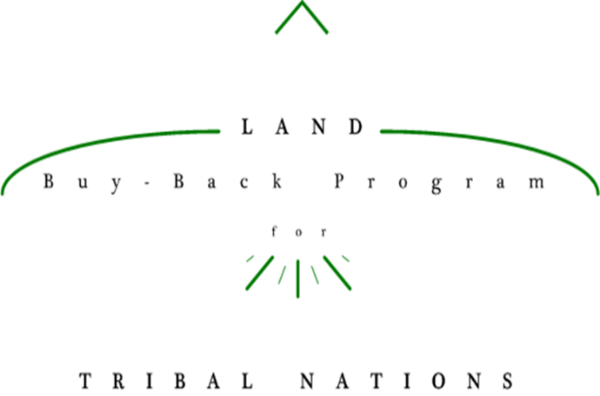

**The <Reservation Name> invites interested landowners to learn more about your Land Buy-Back offer.**

**<Name of Event>**

<Date of Event>

<Time Of Event>

<Location of Event>

***<Refreshments will be served! Or other description of additional items>***

**If you cannot make the event, you can call the Trust Beneficiary Call Center at 1-888-678-6836 with any questions or visit the <BTFA Agency Name>.**

Must receive Tribal approval to use crest/seal..

<Insert Tribal Crest/Seal>

**Land Buy-Back Program**

**Offers Due by <Month/Day>**

<SAMPLE IMAGE ONLY>