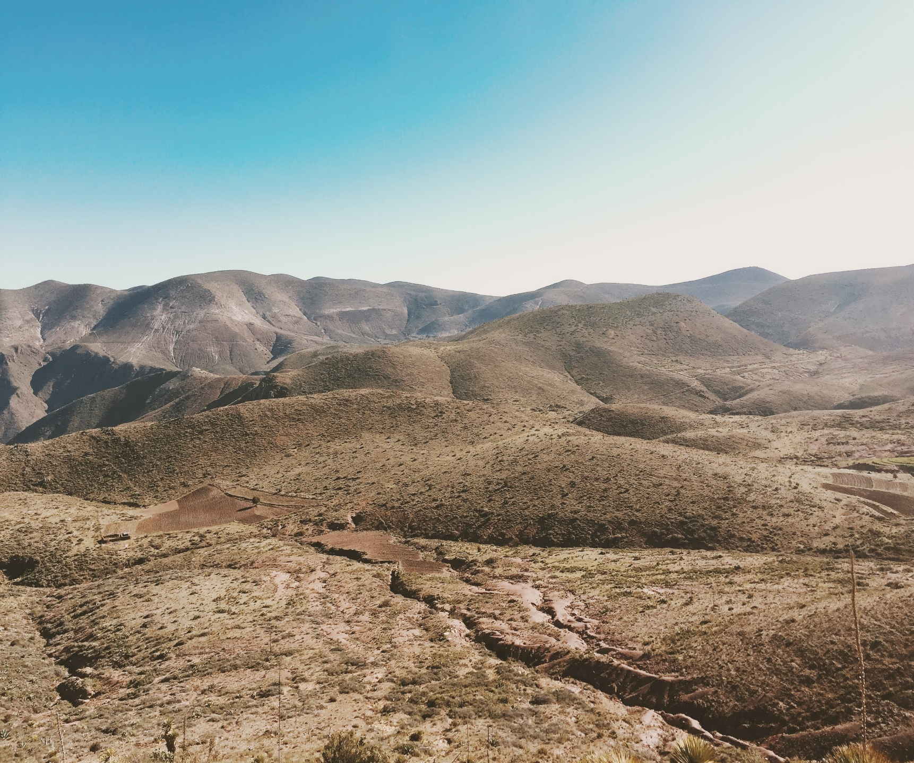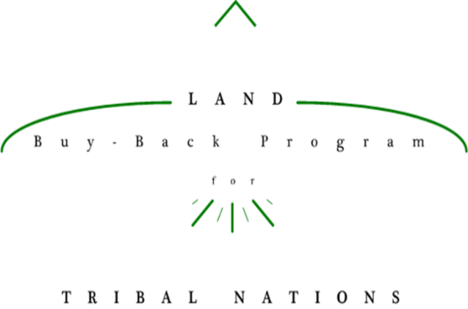

Must receive Tribal approval to use crest/seal.

<SAMPLE IMAGE ONLY>

**If you own land at <Reservation Name>, you can take these steps now:**

* **Make sure your account information is up to date by calling the Trust Beneficiary Call Center at 1-888-678-6836**
* **Visit or call our Tribal Office at <Address and Phone Number> to learn more about the Program**
* **Visit <Local BTFA Agency> to learn more about your land**

<Insert Tribal Crest/Seal>

**Land Buy-Back Program**

**for Tribal Nations**

**Coming Soon!**