**The Land Buy-Back Program for Tribal Nations is coming to the <Insert Reservation Name>**

Must receive Tribal approval to use crest/seal. If not approved use Buy-Back logo.

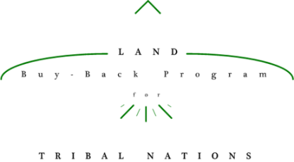

<Insert Tribal Seal/Crest>

**How can I learn more?**

For more information, visit <our/the Program’s> website at

<Insert Tribal Buy-Back website or www.doi.gov/buybackprogram>

You can also <visit our office, call us, or email us> at:

<Tribal Office Address>

<Tribal Office Phone Number>

<Tribal Email Address>

The first step is to ensure that your IIM Account information is up to date. You can update your account information by calling the Trust Beneficiary Call Center at 1.888.678.6836 or visiting the <Insert BTFA Agency Name>. You can also register as a willing seller, indicating your interest in participating in the Program

**What cAN i DO nOW?**

By selling your interests through the Program, you will help create opportunities to make our land more productive for the <Tribe Name> and our community.

**What will happen to my land?**

The Land Buy-Back Program for Tribal Nations is part of the $1.9 billion Cobell Settlement agreement with the Department of the Interior to consolidate fractionated land for the interest of tribal communities.

**What is the Land Buy-Back Program?**