U.S. Department of the Interior

Annual Report on Technology Transfer

FY 2018 Activities

June 2019

DISCLAIMER
Reference herein to any specific commercial products, process, or service by trade name, trademark, manufacturer, or otherwise, does not necessarily constitute or imply its endorsement, recommendation, or favoring by the United States Government, and must not be used for advertising or product endorsement purposes.

Table of Contents

Disclaimer

Cover Photograph

- Introduction
- Advancing Technology Transfer in the Department of the Interior
FY 2018 Accomplishments
- Overview of Technology Transfer Activities
- Technology Transfer Agreements
- U.S. Geological Survey
- U.S. Fish and Wildlife Service
- Office of Surface Mining Reclamation and Enforcement
- National Park Service
- Bureau of Reclamation
- Bureau of Safety and Environmental Enforcement
- Bureau of Ocean Energy Management
- Bureau of Land Management
- Conclusion

Data Appendix
Frequently-Used Acronyms

I. Introduction
Technology transfer for the Department of the Interior (Department) includes a range of activities designed to disseminate scientific and technical information and knowledge between the Department, other Federal agencies and non-Federal entities. It includes, but is not limited to, publishing and exchanging scientific and technical information, protecting and licensing intellectual property rights, and sharing — or otherwise making available — for scientific or technical purposes the expertise and specialized scientific material and resources that the Department manages. The technology transfer activities within the Department are consistent with its mission to protect and manage the Nation’s natural resources and cultural heritage, to make available scientific and other information about those resources, to honor trust responsibilities to Tribes, and to supply energy for the future.

This report describes the actions that the Department took in FY 2018 to advance technology transfer. These range from developing new technologies that would help identify various substances in water to improved methods to measure water quality in high biofouling environments. These activities demonstrate the innovation, expertise and dedication of the Department’s employees, including its many scientists and engineers, to help reduce risks to public health, safety and the environment from natural and man-made hazards. The Data Appendix provides cumulative data tables requested by the Office of Management and Budget, and the National Institute of Standards and Technology for the Department for FYs 2012–2018. These tables include updates to previous years’ data where appropriate.

II. Advancing Technology Transfer in the Department of the Interior

The FY 2018 enacted budget for the Department of the Interior included $909.3 million for research and development. The majority of the funding was for applied research ($689.6 million), while basic research and basic development received $77.1 million and $142.6 million, respectively. The programs supported through these funds generate new and improved knowledge, information, and technology, which help the Department meet its mission objectives and are transferred to resource managers, stakeholders, and the general public.

The Department’s bureaus have varying levels of involvement with scientific and technical research and innovation, and technology transfer. In FY 2018, as in previous years, the majority of technology transfer activities reported by the Department under the Federal Technology Transfer Act of 1986 (FTTA) were undertaken by the U.S. Geological Survey (USGS), which is the largest research and development (R&D) organization in the Department, both in terms of budget and personnel. Typically, USGS accounts for over 70 percent of the Department’s R&D budget.

The Department’s scientists, engineers, and other technical personnel advance the state of knowledge related to the resources it manages, and ensure that this information is accessible to resource managers, private industry, and the general public. The vast majority of the Department’s technology transfer activities use traditional technology transfer mechanisms, such as publications of peer reviewed papers and reports, webpage postings, fact sheets, and presentations at meetings and conferences. In 2018, DOI personnel authored or co-authored over 12,300 reports, books, fact sheets, and other publications, including almost 4,500 scientific publications.

Bureaus also use other conventional approaches to share scientific and technical resources and expertise with each other, universities and other entities to address resource management issues. For example, seven DOI bureaus are active participants in the network of 17 Cooperative Ecosystem Studies Units (CESUs), a collaboration among 15 Federal agencies and more than 400 non-Federal partners (including universities, Tribes and tribal organizations, state agencies, museums, aquariums, arboretums, and conservation organizations). Each CESU is hosted by a university.

In addition, some bureaus and/or offices have offered prizes to help develop new or improve existing technologies. The bulk of the prize competition activities at DOI are undertaken by the Bureau of Reclamation’s Water Prize Competition Center (WPCC). In FYs 2017-2018, the WPCC completed, had underway or launched 15 prize competitions which included 14 from the WPCC and one jointly offered by the National Invasive Species Council, DOI’s Office of Hawaiian Affairs, and other DOI bureaus. Reclamation plans to launch 17 more competitions over the next few years.

Bureaus that are active in research and development, or have research capabilities that complement U.S. commercial interests, may also utilize technology transfer agreements authorized by the FTTA to join forces with non-Federal partners. Such agreements allow the Department’s bureaus and private sector industries to pool their expertise and resources to jointly create and advance technologies that could help fulfill agency missions while helping U.S. industries innovate and commercialize technologies, which can strengthen our national economy and create jobs. This report focuses primarily on, but is not limited to, aspects of technology transfer related to the FTTA.

FY 2018 Accomplishments

During FY 2018, the Department’s scientific, technical, and engineering personnel continued to engage in a broad range of cooperative activities to develop and disseminate innovative technologies, including:

- Publishing over 10,500 reports, books, papers, fact sheets, and other publications, including almost 4,500 in scientific publications.
- Collaborating on 740 Cooperative Research & Development Agreements (CRADAs), of which 422 were initiated in FY 2018. In addition, the Department engaged in at least 249 other collaborative R&D relationships.

- Engaging in 687 non-traditional CRADAs, such as material use and facility use agreements, under the FTTA.
- Disclosing nine (9) new inventions. In addition, seven (7) patents were filed and six (6) patents were received.
- Managing 17 active licenses for inventions and other intellectual property earning about $51,000 collectively.

III. Overview of Technology Transfer Activities

Table 1 shows that the Department’s bureaus use or are contemplating using a variety of mechanisms to transfer information, knowledge, and technology within and outside their agencies.

Table 1: Principal Technology Transfer Mechanisms Identified by Each Bureau

 | USGS | FWS | OSMRE | NPS | BSEE | Reclam-ation | BOEM | BLM
Technical/Scientific Publications | X | X | X | X | X | X | X | X
Workshops/Seminars | X | X | X | X | X | X | X | X
Educational Courses & Other Outreach | X | X | X |  | X | X | X | X
Cooperative Research and Development Agreements (CRADAs) | X | X |  | X |  | X
Technical Assistance Agreements (TAAs) | X
Facility Use/Service Agreements (FUSAs) | X |  |  |  |  | X
Material Transfer Agreements | X |  |  | X |  | X
Demonstration/Joint Projects |  |  |  |  | X | X |  | X
Patents | X | X |  | X |  | X
Licenses | X | X |  | X |  | X
Other Cooperative Ventures & Agreement Types | X | X | X | X | X | X
Web and other mechanisms | X | X | X | X | X | X | X | X

IV. Technology Transfer Agreements

Table 2 provides a summary of new and active technology transfer agreements undertaken within the Department in FY 2018. There were a total of 740 active CRADAs in FY 2018, of which 422 were newly executed. In FY 2017, there were a total of 841 CRADAS (including 477 new ones).

 |  | Table 2: Collaborative Relationships for Research & Development (FY 2018)
 |  |  | USGS | Recla-mation | NPS | BOEM | FWS | Total
● CRADAs, total active in the FY⁽¹⁾ |  |  | 726 | 12 | 2 | 1 | 1 | 740⁽⁵⁾
- New, executed in the FY |  |  | 418 | 3 | 1 | 0 | 0 | 422
▪ Traditional CRADAs,⁽²⁾ total active in the FY |  |  | 49 | 3 | 1 | 1 | 1 | 53⁽⁵⁾
- New, executed in the FY |  |  | 4 | 1 | 0 | 0 | 0 | 5
▪ Non-traditional CRADAs,⁽³⁾ total active in FY |  |  | 677 | 9 | 1 |  | 0 | 687
- New, executed in the FY |  |  | 414 | 3 | 1 |  | 0 | 418
● Other collaborative R&D relationships⁴
▪ (Collaborative Agreements), total active in the FY |  |  | 249 |  |  |  |  | 249
- New, executed in the FY |  |  | 117 |  |  |  |  | 117
CRADA = Cooperative Research and Development Agreement
(1) “Active” = legally in force at any time during the FY. “Total active” is comprehensive of all agreements executed under CRADA authority (15 U.S.C. § 3710a).
(2) CRADAs involving collaborative research and development by a federal laboratory and non-federal partner.
(3) CRADAs used for special purposes -- such as, material transfer or technical assistance that may result in protected information. For USGS, Technical Assistance Agreements (TAA) and Facility Use/Service Agreement (FUSA) fit this category.
(4) Based on available data. These figures do not account for the majority of collaborative agreements that bureaus engage in under authorities other than the FTTA.
(5) For 2018, this number is two less than the sum of the preceding columns because one CRADA involved three bureaus: BOEM, FWS, and USGS.

Table 3 summarizes invention and patenting activity within the Department during FY 2018 broken out by bureau. The table indicates that twelve new inventions were disclosed, five new patent applications were filed and three new patents were issued.

 |  | Table 3: Invention Disclosure and Patenting (FY 2018)
 |  |  | USGS | Recla-mation |  | NPS |  |  | FWS |  | Total
● New inventions disclosed in the FY⁽¹⁾ |  |  | 7 | 2 |  | 0 |  |  | 0 |  | 9
● Patent applications filed in the FY⁽²⁾ |  |  | 6 | 1 |  | 0 |  |  | 0 |  | 7
● Patents issued in the FY |  |  | 4 | 0 |  | 1 |  |  | 1 |  | 6

Table 4 provides a summary of the number of active licenses managed by the Department’s bureaus.

Table 4: Active and Income Bearing Licenses (FY 2018)

 | USGS | Reclam-ation | Total
● All licenses, number, total active in the FY | 13 | 4 | 17
▫ New, executed in the FY | 2 | 0 | 2
● Income bearing licenses | 11 | 2 | 13

Total income in FY 2018 from all licenses amounted to about $51,000 (from 13 income bearing licenses), compared to $50,000 (also from 13 income-bearing licenses in the previous fiscal year).

Table 5 provides a summary of the scope and nature of technology transfer activities and mechanisms that the various bureaus implement currently or might implement in the future.

Table 5: Scope of Activities and Plans Related to the FTTA, by Bureau

Mission | Technology Transfer
U.S. Geological Survey (USGS). The mission of the USGS is to serve the Nation by providing reliable scientific information to describe and understand the Earth, minimize loss of life and property from natural disasters, manage water, biological, energy, and mineral resources, and enhance and protect our quality of life. | The USGS serves the Nation as an independent fact-finding agency that collects, monitors and analyzes scientific and technical information to provide scientific understanding about natural resource conditions, issues, and problems. The USGS makes this information and knowledge readily available to decision-makers and the public. Thus, one of the USGS’s main thrusts is broad and open dissemination of its knowledge and information. USGS also pursues technology transfer opportunities under the FTTA and the Stevenson-Wydler Act in a variety of ways (see Table 1).
U.S. Fish & Wildlife Service (FWS). The mission of the FWS is working with others to conserve, protect, and enhance fish, wildlife, and plants and their habitats for the continuing benefit of the American people. | FWS’s Research and Development (R&D) is primarily focused on providing the basis for effective conservation to meet its mission. For example, the FWS Fish Technology Centers were established in 1965 to develop and improve fish culture technology and to provide assistance to Federal and State agencies, Tribes, and other nations interested in aquaculture research and solutions. They have worked with industry and government to improve aquaculture opportunities.
Office of Surface Mining Reclamation and Enforcement (OSMRE). The OSMRE is responsible for ensuring, through a nationwide regulatory program, that coal mining is conducted in a manner that protects communities and the environment, restores the land to beneficial use following mining, and mitigates the effects of past mining by aggressively pursuing reclamation of abandoned mine lands. | OSMRE advances its mission by providing technical assistance, based on sound science and training, to its State and Tribal partners to enhance their ability to maintain effective programs. Although OSMRE has no formal research and development activities, its Technology Development and Transfer program promotes and disseminates information on technological innovations to better protect the environment during mining and in reclaiming and restoring active and abandoned mines. The program also provides training to ensure that States, Tribes, and OSMRE’s other partners continue to administer their surface mining programs efficiently and effectively.
National Park Service (NPS). The National Park Service preserves unimpaired the natural and cultural resources and values of the national park system for the enjoyment, education, and inspiration of current and future generations. The NPS cooperates with partners to extend the benefits of natural and cultural resource conservation and outdoor recreation throughout this country and the world. | Technology transfer and employee inventions are addressed under the NPS benefits-sharing policy and procedural guidance (available at http://www.nps.gov/applications/npspolicy/DOrders.cfm). Benefits sharing occurs when NPS receives monetary or non-monetary benefits from the commercial use of a discovery or invention resulting from research originating under an NPS Scientific Research and Collecting Permit, or other NPS permit or authorization. Authorities under the FTTA are essential to the NPS benefits-sharing program.
Bureau of Safety and Environmental Enforcement (BSEE). The BSEE works to promote safety, protect the environment, and conserve resources offshore through vigorous regulatory oversight and enforcement. | The BSEE R&D program operates through the Emerging Technologies Branch (ETB) and the Oil Spill Response Research program (OSRR) in the Response Research Branch. BSEE research is associated with operational safety, pollution prevention, and oil spill cleanup techniques and technologies. BSEE research results are used to inform regulatory decision making and to promote the use of Best Available and Safest Technology on the U.S. Outer Continental Shelf.
Bureau of Reclamation (Reclamation). The mission of the Bureau of Reclamation is to manage, develop, and protect water and related resources in an environmentally and economically sound manner in the interest of the American public. | Reclamation has the lead Federal responsibility for water management and hydropower in the 17 Western States. Its research program is highly applied towards the development of solutions that increase efficiency, reduce maintenance costs, improve work safety, enhance infrastructure reliability, and increase the effectiveness of using desalination and other water treatment technologies to expand water supplies. The research programs use technology transfer fundamentals to help speed field deployment of new innovations.
Bureau of Ocean Energy Management (BOEM). The BOEM manages the exploration and development of the Nation’s offshore energy and mineral resources in an environmentally and economically responsible way. It seeks to appropriately balance economic development, energy independence, and environmental protection through oil and gas leases, renewable energy development and environmental reviews and studies. | BOEM’s Environmental Studies Program (ESP) develops, conducts and oversees scientific research specifically to inform policy decisions regarding development of Outer Continental Shelf (OCS) energy and mineral resources. Research covers physical oceanography, atmospheric sciences, biology, protected species, social sciences, economics, submerged cultural resources, and environmental fates and effects. BOEM also funds research into offshore renewable energy technology.
Bureau of Land Management (BLM). The BLM mission is to sustain the health, diversity, and productivity of America’s public lands for the use and enjoyment of present and future generations. The Federal Land Policy and Management Act of 1976 (FLPMA) mandates that the BLM manage public land resources for a combination of balanced and diverse resource uses that takes into account the long-term needs of future generations for renewable and non-renewable resources, including, but not limited to, recreation, range, timber, minerals, watershed, wildlife and fish, and natural scenic, scientific and historical values | BLM’s science and technical focus has been on place-based applications to improve the management of public lands in accordance with FLPMA’s multiple use mandate. Accordingly, it focuses on traditional technological transfer activities to help advance its multiple-use mandate.

Subsequent sections briefly describe each bureau’s technology transfer program and a sample of their activities in FY 2018. The tabular data requested by OMB Circular A-11 are reported in the Data Appendix, to the extent data are available.
V. U.S. Geological Survey

The United States Geological Survey (USGS) is a science bureau within the Department of the Interior whose mission is to serve the Nation by providing reliable scientific information to describe and understand the Earth, minimize loss of life and property from natural disasters, manage water, biological, energy, and mineral resources, and enhance and protect our quality of life. The USGS focuses on the following interdisciplinary mission areas: Ecosystems; Land Resources; Energy and Minerals; Environmental Health; Natural Hazards; Water Resources; and Core Science Systems. The combined expertise from several Earth Science disciplines (e.g., hydrology, geology, biology) address relevant issues of concern to people and other living things on the planet. Organization around these mission areas allows the USGS to better address the needs of the Nation, its customers, and partners.
Delivery of science information is a primary purpose of the bureau. Technology transfer activities with the public and private sectors, including academia and non-profits, are, therefore, integral to fulfilling this purpose. They typically support knowledge dissemination, including the collection and transfer of scientific data. In FY 2018, the U.S. Geological Survey personnel, for example, authored or co-authored 10,102 reports, books, fact sheets, and other publications and information products, including over 2,634 scientific journal articles, 680 USGS Series scientific publications, 1,285 data releases, and 3,972 abstracts. The USGS also cooperates with its public and private collaborators to help them maintain essential and necessary services, better understand the environmental consequences of their commercial and non-commercial activities, and develop new products and services. The USGS has 361 major laboratories and several hundred field offices located around the country.
Within the USGS, technology transfer that extends beyond traditional publications, meetings, and conferences, and is related to the Stevenson-Wydler Innovation Act and the FTTA is managed through the Office of Policy and Analysis (OPA). OPA staff service USGS Science Centers and offices throughout the country.
OPA, on behalf of the USGS, negotiates and drafts Cooperative Research and Development Agreements (CRADAs), Technical Assistance Agreements, Facility Use Agreements, Material Transfer Agreements, and Patent Licenses. OPA also manages the USGS intellectual property and inventions program; markets USGS technology opportunities; and facilitates partnerships with industry, non-profits, academic institutions, Tribal nations, and State agencies. OPA also provides training to USGS personnel on technology transfer and intellectual property matters.
In 2018, USGS had 726 active traditional and non-traditional CRADAs, the majority of which (677) were technical assistance and facility use agreements. By contrast, in FY 2017 it had 817 active CRADAs, including 768 non-traditional CRADAs. In addition, in FY 2018, USGS executed 249 other collaborative agreements, managed a total of thirteen (13) active licenses. It also filed six (6) patent applications and received four (4) patents.
USGS science and research contributes to a broad range of collaborative projects in the private and academic sector. The USGS provides unique analytical laboratory services to domestic, foreign, and academic partners through the USGS Facility Use program. Examples include:

ShakeAlert – An Earthquake Early Warning System. The U.S. Geological Survey (USGS) has formed partnerships with both public and private entities to develop an earthquake early warning (EEW) alert system called ShakeAlert. The system has the potential to have a significant impact because earthquakes pose a national challenge, with more than 75 million Americans living in areas of significant seismic risk. The Federal Emergency Management Agency (FEMA) has estimated that the average annual loss from earthquakes is $5.3 billion.

The USGS, through its CRADA authority, collaborated with several organizations—including the California Geological Survey, Caltech Seismological Laboratory, Berkeley Seismological Laboratory, USGS Menlo Park, USGS Pasadena, and the California Governor's Office of Emergency Services—to form the California Integrated Seismic Network (CISN) to monitor earthquakes and collect data to support improvements to earthquake resilience. CISN also collaborated with other seismic networks, such as the Advanced National Seismic System (ANSS), to detect earthquakes’ first wave (p-wave) and the more damaging subsequent transverse and surface waves. This collaboration enables USGS and ANSS to leverage their substantial investment in sensor networks, data telemetry systems, data processing centers, and software for earthquake monitoring activities residing in these network centers.

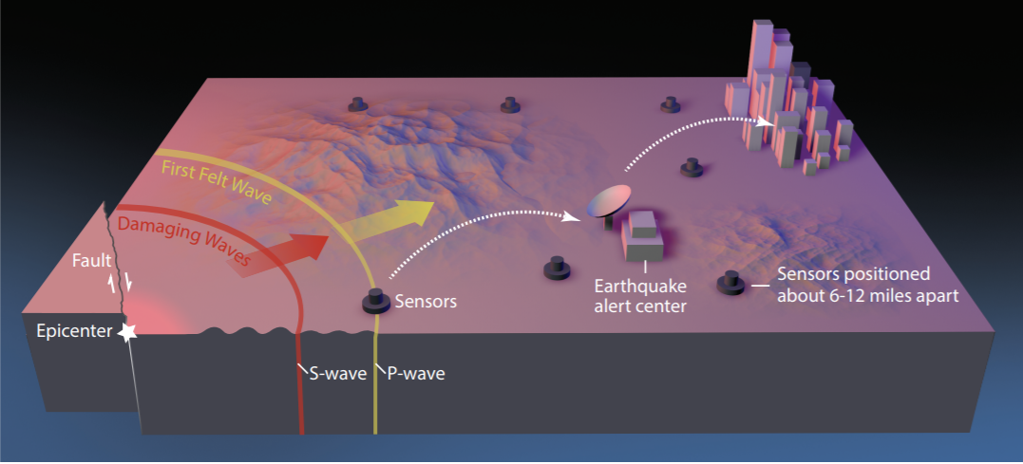
Earthquake early warning systems like ShakeAlert work because the warning message can be transmitted almost instantaneously while shaking waves from the earthquake travel through the Earth at speeds of a few miles per second. When an earthquake occurs, seismic waves—including compressional (P) waves, transverse (S) waves, and surface waves—radiate outward from the epicenter. The faster but weaker P waves trip nearby sensors, causing alert signals to be sent out, giving people and automated electronic systems some time (seconds to minutes) to take protective actions before the arrival of the slower but stronger S waves and surface waves. Computers and mobile phones receiving the alert message can calculate the expected arrival time and intensity of shaking at your location. USGS image created by Erin Burkett (USGS) and Jeff Goertzen (Orange County Register).

More information can be obtained at the following sites:
- https://pubs.usgs.gov/fs/2014/3083/pdf/fs2014-3083.pdf
- https://www.federallabs.org/successes/success-stories/usgs-and-partners-develop-earthquake-early-warning-technology-under-crada
- https://www.pbs.org/newshour/show/how-this-earthquake-alert-app-could-give-the-west-coast-vital-warning

ABEM, Inc. – Time-Domain Electromagnetic Instrument. The Earth System Processes Division (ESPD) Hydrogeophysics Branch supports U.S. Geological Survey (USGS) Water Science through geophysical method development research and provision of technical support and guidance on the use of geophysical methods for groundwater investigations and other applications of near-surface geophysics. The Branch currently utilizes time-domain or transient electromagnetic (TEM) methods for site characterization and monitoring projects and has a need for advanced static and mobile TEM systems and methodology. The purpose of this CRADA is to provide a framework for cooperation between the USGS and ABEM for development, testing, evaluation, and documentation of innovative TEM methods for groundwater and other near-surface geophysical investigations. Improvements in TEM instrumentation will improve the efficacy and efficiency of geophysical investigations involving the detection and assessment of groundwater. ABEM will provide advanced equipment and software, and USGS will test and evaluate the equipment at a broad range of USGS field sites. This work will benefit the USGS by providing access to state-of-the-art equipment and software and to advanced methodologies for groundwater investigations which will facilitate continued USGS leadership in the field of hydrogeophysics.
Academy of Natural Sciences of Drexel University CRADA – “Quantifying Floodplain Ecological Processes and Ecosystem Services.” Floodplain and wetland areas lie at the intersection of terrestrial and aquatic systems, serving as biogeochemical “hotspots” for material transformations and nutrient processing within a watershed. During flood events, when the bulk of downstream discharge and pollutant loading occurs, floodplain topographic features and vegetation slow the water velocity. This allows for settling and deposition of sediments and increases the opportunity for nutrient uptake and processing. The capacity of the floodplain ecosystem to retain sediment, nutrients, and floodwaters provides critical ecosystem services to local and downstream communities in the Delaware River Watershed (DRW). Ecosystem services are defined as the benefits to people provided by or via the natural environment. For example, nutrient retention within a floodplain supports high water quality, which is important for fish and other wildlife. As a result, recreational activities (such as fishing, boating, wildlife watching), would (or should) increase, as would the value of those services. However, the ability of floodplains to provide functions and services vary depending on human land use and management decisions, as well as natural hydrogeomorphic variation. To make informed decisions about location-specific tradeoffs between land use planning and conservation, stakeholders need a better understanding of the services provided by floodplains in their specific areas.

Quantifying ecosystem services by linking ecosystem function to values, offers a framework to assess the value provided by floodplains and the tradeoffs associated with land management decisions.

Currently, there is a lack of knowledge specific to the Delaware River Watershed on how floodplain ecosystem functions translate into ecosystem services and values. The intention of this CRADA with the Academy of Natural Sciences of Drexel University is to fill this knowledge gap by leveraging and building upon floodplain function and ecosystem service methods developed for the Chesapeake Bay watershed. This will be accomplished through a combination of fieldwork, mapping, and modeling for the DRW. This assessment of floodplain condition and associated ecosystem services will help identify areas for targeted management in order to maintain areas with high ecosystem service values, and to restore areas that could provide the most ecosystem service benefits.

The goals of this project are to 1) inform Delaware River Watershed Initiative (DRWI) to conserve and restore water quality and overall ecological health, and 2) facilitate strategic targeting of conservation and restoration actions within the floodplain of the DRW.

Afghanistan – “Potential lithium brine resources in Dasht-e-Nawur in Ghazni province and Namaksar-e-Herat of the Herat province.” The USGS was requested to conduct a series of field projects within Afghanistan. There were several subsequent projects performed in coordination with the Department of Defense, Task Force for Business and Stability Operations (DoD-TFBSO) in 2010/2011. Recently, the Afghan Government has requested to partner with the USGS geologists who are familiar with Afghanistan’s geology and potential Lithium areas of interest. Lithium is in high demand for its use in lightweight batteries because of its low density and high electrical conductivity.

The USGS and the Ministry of Mines and Petroleum of the Islamic Republic of Afghanistan entered into a Technical Assistance Agreement (TAA) to establish a framework under which the USGS will conduct geological studies of mineral resources in Afghanistan and to further define Phase I of the project activity. It comprises of studies on the potential lithium brine resources in Dasht-e-Nawur in Ghazni province and Namaksar-e-Herat in the Herat province and the Godzareh East and Godzareh West dry lakes, both in Nimroz Province, and hard-rock deposits of spodumene (a lithium ore) in Kunar province.

Patents

In FY2018, USGS was awarded four patents.

U.S. Patent No. 9,995,282 addressed the concern of animal fatalities including bats that fly into the moving blades of Wind turbines. This led USGS researchers, in collaboration with private and university partners, to develop a bat deterrent system that uses ultraviolet light in a specific range not perceptible to humans. Unexpectedly, it was found that a specific range of UV light deters animals such bats from being attracted to the turbine. Turbine systems using USGS technology could be placed in residential areas avoiding the nuisance caused by bright lights illuminating an area that humans could see.

U.S Patent No. 9,921,139 is for a portable, hand-held sampler for collection of aquatic biotic samples. It allowed for underwater samples to more easily be captured. By its design, it can provide continuous flow allowing for multiple samples to be taken without someone like a diver being required to come to the surface between samples.

U.S. Patent No. 9,903,817 provides for a self-contained dissolved gas sensor system with high precision that includes its own internal power source, processor and memory. The design provides greater protection of sensor components due to its compact, integrated housing.

U.S. Patent No. 9,823,169 is a sampler capable of collecting large quantities of fugitive dust directly from suspension at the time of generation from the moving vehicle before it interacts with other substrates in the immediate environment. Using an innovative approach, small particulates are separated from the dust through a cyclone and filter within the sampler to enable sufficient amounts of the particulates to be analyzed. This allows for the characterization of the particulates so that potential causes or concern for health hazards may be readily determined.

VI. U.S. Fish and Wildlife Service

The U.S. Fish and Wildlife Service (FWS) is dedicated to the conservation, protection, and enhancement of fish, wildlife and plants, and their habitats. FWS is the only agency in the Federal Government whose primary responsibility is managing fish and wildlife resources for the American public. It manages more than 855 million acres of lands and waters in the National Wildlife Refuge System, including seven national monuments, 567 national wildlife refuges, and 210 Waterfowl Production Areas. FWS also operates National Fish Hatcheries, which, in conjunction with its Fish Health Centers and Fish Technology Centers (including the Conservation Genetics Lab in Alaska), restore native aquatic populations, mitigate for fish lost as a result of Federal water projects, and support recreational fisheries throughout the United States.
Research and Development (R&D) within FWS is primarily focused on applying the latest scientific and technical information to fulfill its mission of working with others to conserve, protect, and enhance fish, wildlife, plants, and their habitats for the continuing benefit of the American people. Transferring FWS’s technology and knowledge to the public and collaborators accelerates the adoption and use of agency research while improving the economic and societal benefit from its R&D investments to help solve natural resource problems.

The technology transfer function of FWS is shared among several programs, including Science Applications; Fish and Aquatic Conservation (FAC); and Policy, Performance, and Management (PPM) Programs. The vast majority of FWS’s technology transfer is done via dissemination to the public and scientific community through traditional avenues such as peer-reviewed papers, reports, and fact sheets.
FWS employees are actively involved in the larger scientific community and participate in scientific societies, meetings and conferences, and publish scientific research. Sharing scientific and technical information via public outreach and partnerships is a high priority for FWS. For example, the FWS is a partner to all units within the 17 Cooperative Ecosystem Studies Units (CESU) Network, allowing FWS to be involved in interdisciplinary and multi-agency research projects with the host university and other non-federal partners. Each year the FWS pursues dozens of projects through the CESU network including surveying and monitoring efforts, climate change vulnerability assessments, streamflow projections, and many others.
Scientists within the agency published 443 scholarly articles, papers, or book chapters in publications focused on diverse topics such as ecology, biodiversity conservation, fisheries, zoology, ornithology, environmental sciences, and evolutionary biology. FWS also manages two online peer-reviewed publications focused on the practical application and integration of applied science to wildlife conservation and management — the Journal of Fish and Wildlife Management and the North American Fauna Monograph Series. These electronic journals are in the public domain. FWS also uses its research to help inform a wide range of wildlife management decisions in the interest of the general public. For example, the National Wildlife Refuge Inventory and Monitoring Program systematically obtains a range of biological data about the status, trends and management responses of species and habitats within the Refuge System. Those data inform and improve the conservation of fish, wildlife, and plant natural resources. In 2018, the two scientific journals were queried over 138,150 times in scholarly searches.
Patents: In FY 2018, FWS received a patent for a handheld data-logging apparatus (U.S. Patent No. 9,788,536), which helps fight invasive plant species on both public and private lands. The apparatus incorporates a global positioning system (GPS) receiver and microcontroller integrated into a conventional handheld spray unit. As an operator dispenses a chemical using the apparatus, the microcontroller records several data points including the volume of chemical dispensed and the GPS location of the sprayer. The recorded data is processed and stored on a removable USB thumb drive. The operator can download the data from the thumb drive and manipulate the data using a conventional spreadsheet program or a commercially-available geographic information system program.

The patent adds to the four patents obtained by FWS since 1998. These include patents, such as one for calcein detection devices developed at the FWS Northeast Fishery Center in Lamar, PA, for detecting non-invasively-marked hatchery-reared Atlantic salmon for up to 3 years post-marking, which has been licensed exclusively to Western Chemical (Ferndale, Washington).

In addition, at the end of FY 2017, the World Wildlife Fund filed a patent application (Serial No. 15/675,630) on behalf of a FWS employee and contractor for a pellet delivery mechanism that delivers plague vaccines to prairie dogs, which can also indirectly benefit black footed ferrets that are on FWS's Endangered Species List.

CRADAs: In FY 2018, FWS maintained two CRADAs it has in place through the Aquatic Animal Drug Approval Program (AADAP) within FAC. FWS also maintains a joint CRADA involving USGS and BOEM (on behalf of DOI) and Bird Studies, Canada, which was entered into in FY 2017.
Following is a brief description of FWS programs and entities engaged in technology development and transfer activities.
National Conservation Training Center. The FWS Conservation Library at the National Conservation Training Center (NCTC) in Shepherdstown, West Virginia, provides a searchable collection of selected documents, images, historical artifacts, audio clips, publications, and video, most of which are in the public domain. FWS also makes internal publications, reports, and other information available to the public through the FWS website. Collections of current and legacy publications (including biological and technical publications) are available online from the NCTC library catalog and websites. NCTC also maintains links to biological and technical publications, as well as additional publications regarding birds, wetlands, fish hatcheries, and National Wildlife Refuges.
NCTC also hosts publicly-accessible webinars dealing with a variety of scientific and technical issues that affect the nation’s fish and wildlife resources. During FY 2018, NCTC hosted 60 online science, technology, and educational webinars; 70 e-courses; and 33 podcasts related to managing the nation’s fish, wildlife, and plant resources. These are an important component of FWS’s traditional technology transfer activities.
Fish and Aquatic Conservation Program. FWS’s primary research nexus with the private sector centers on programs and facilities within the Fish and Aquatic Conservation (FAC) Program. The program includes a network of Fish Hatcheries, Fish and Wildlife Conservation Offices, Fish Health Centers, Fish Technology Centers, the Conservation Genetics Laboratory in Anchorage, Alaska, and the Aquatic Animal Drug Approval Partnership (AADAP). These centers and programs provide assistance and support to conservation partners of FWS, including Federal, State, tribal, and non-governmental organizations that cover a broad range of disciplines including biostatistics, population ecology, genetics, nutrition, and fish health and pathology. FWS’s Fish Health Centers, Fish Technology Centers, and AADAP play an integral role in applied science and technology transfer.
FWS Aquatic Animal Drug Approval Partnership. AADAP is the only program in the United States singularly dedicated to obtaining U.S. Food and Drug Administration (FDA) approval of new medications needed for use in fish culture and fisheries management. Since the late 1990s, AADAP has contributed to virtually every new fish medication approved by the FDA. Ultimately, the AADAP program allows fisheries professionals to more effectively and efficiently rear and manage a variety of fish species to meet production goals, stock healthy fish, and maintain a healthy environment.
Fish Technology Centers. Most of the Fish Technology Centers (FTCs) were established in 1965 to develop and improve fish culture technology and provide assistance and advice on fish culture to National Fish Hatcheries, other Federal and State agencies, Tribes, other Nations, and the aquaculture industry. The FTCs provide applied science products and transfers technology related to fish and fisheries for the Nation. The FTCs have developed culture techniques and fish diets now used around the world, including dehydrated long-lasting feeds that revolutionized the fish-culture industry. Results of studies conducted by FWS scientists are published in peer-reviewed journals, and management recommendations are communicated within the Service and to our partners through conservation science partnerships.
- Nutrition and Diet Development Laboratories. These facilities allow for the manufacture of experimental larval, fingerling, and broodstock fish feeds and the testing of many different kinds of ingredients to improve fish nutrition, performance, and quality. This program also develops specialized diets for use in captive rearing of endangered fish species.
- Physiology Laboratories. These laboratories support conservation- and management-related needs of FWS and its partners, including, but not limited to, understanding the physiological needs of fish to support conservation and/or commercial opportunities.
- Conservation Genetics Laboratories. These laboratories support conservation and management related needs of FWS and its partners, including, but not limited to: (a) using genetic DNA methods to meet real-time fishery needs to conserve and manage species; (b) assisting with Endangered Species Act status reviews and recovery planning via baseline data on genetic population structures and genetic monitoring and evaluation of listed populations and species; (c) establishing and maintaining genetic tissue/DNA repositories for imperiled species; and (d) characterizing diversity within and among wild populations.
- Ecology Laboratories. These laboratories focus on understanding the physiological requirements and tolerances of threatened and endangered species. Less-invasive or non-invasive tools, such as measurement of plasma sex steroids and ultrasound, are used to determine gender, stage of sexual maturity, and spawn readiness of individual fish in wild and captive populations of threatened and endangered species. These laboratories also provide contract services to federal and state agencies, universities, and NGOs for a variety of analyses employing these less-invasive tools, as well as blood chemistry analysis, histology, proximate analysis, and radio-immunoassays.
- Fish Health Centers. FWS’s Fish Health Centers play an integral role in applied science and technology transfer. Their scientists are leaders both nationally and internationally in the diagnosis of wildlife diseases and in the science of aquatic animal health, developing and validating tests that benefit, and are adopted by, the aquaculture industry. Fish Health Centers work closely with Federal, State, Tribal, academic, and NGO partners to promote the scientific management of fisheries and aquaculture by reducing the effects of wildlife pathogens.
Aquatic Invasive Species. The FWS Aquatic Invasive Species program works to prevent the transfer and introduction of exotic, introduced, non-native, and other potentially harmful species and to develop early detection and rapid response capabilities. For example, the program worked with numerous partners to develop methods for detecting miniscule amounts of free-floating DNA (environmental DNA or eDNA) in water samples to confirm the presence (or absence) of species at levels undetectable by traditional sampling methods. This innovative technology is now being applied widely in monitoring programs and, as it continues to be further developed and refined, will significantly benefit both FWS programs and partners by allowing earlier detections of invasive species.
The FAC program is also applying rapid screening tools it has developed to help determine a species’ risk for invasion. Knowledge of both low- and high-risk species will help industry, states, and consumers make more responsible choices about which species to acquire and use. In addition, these tools will help state agencies make decisions on potentially invasive species and work with industry to manage risky species in their jurisdictions. For example, Michigan’s Public Act 537, established new protections to minimize the risk of invasive species that require, among other things, the use of FWS’s risk assessment protocol.

VII. Office of Surface Mining Reclamation and Enforcement

The Office of Surface Mining Reclamation and Enforcement (OSMRE), established by the Surface Mining Control and Reclamation Act of 1977 (SMCRA), is responsible for ensuring that coal mining is conducted in a manner that protects communities and the environment, restores the land to beneficial use following mining, and mitigates the effects of past mining by aggressively pursuing reclamation of abandoned mine lands. OSMRE achieves this in part by providing technical assistance based on sound science and training to its State and Tribal partners to enhance their ability to maintain effective programs.

The goals that underlie OSMRE’s Technology Development and Transfer program include: (a) increasing the technical knowledge of the reclamation of active and abandoned coal mines; (b) developing and enhancing working relationships among the bureau’s partners in Federal, State, and Tribal governments, and industry and academia; and (c) leveraging its resources through partnerships. OSMRE accomplishes these goals via the Technical Innovation and Professional Services (TIPS) program, the National Technical Training Program (NTTP), and the National Technology Transfer Team (NTTT).

Technical Innovation and Professional Services (TIPS). The goal of TIPS is to provide State, Tribal, and OSMRE personnel with a comprehensive set of analytical tools to aid in technical decision-making related to regulatory and reclamation processes. The services provided are centered on off-the-shelf scientific and engineering computer software and technical hardware supported by OSMRE in partnership with the States and Tribes. TIPS hardware is available for loan to States and Tribes that regulate coal mining in order to advance reclamation projects nationwide.

TIPS is a national program that continues to research and apply emerging technologies to SMCRA workflows. Currently, TIPS assistance includes providing commercial software applications and hardware to State, Tribal, and OSMRE offices at considerable cost savings by sharing the commercial licenses for 28 commercially available software applications via the Internet and OSMRE Wide Area Network. These software applications cover a wide range of regulatory and abandoned mine lands subjects. The customer base covers over 90 State, Tribal, and OSMRE office locations throughout the country – about 2,000 users.

The TIPS suite of scientific, hydrologic, and mapping core software aids the technical decision-making associated with a wide variety of tasks that surface mining agencies have to perform regularly: (1) conducting reviews of permits, (2) performing cumulative hydrologic impact assessments, (3) quantifying potential effects of coal mining, (4) preventing acid mine drainage, (5) quantifying subsidence impacts, (6) measuring revegetation success, (7) assisting in the design of abandoned mine lands projects, and (8) providing the scientific basis for environmental assessments and environmental impact statements.

Demand for TIPS tools and support continues to increase, especially in geospatial data, and mobile computing tools for field use. TIPS is offering more on-site training to accommodate the use of mobile computing devices by inspectors. Mobile computing increases efficiency in resolving issues with primacy State staff and industry. TIPS software users in States, Tribes, and OSMRE logged over 70,000 TIPS core software sessions in the fiscal year (FY) 2018, aiding the permitting process and reclamation of abandoned mine lands.

In addition, the TIPS program continues to develop and enhance the GeoMine Web Application, and conduct training programs using the software and TIPs tools provided to the State, Tribal, and Federal offices to ensure that all agencies with SMCRA responsibilities are using the same advanced software and hardware tools to conduct the business required by the Act. These activities are discussed in more detail below.

- GeoMine Web Application: The GeoMine Web Application, which was developed by OSMRE in collaboration with the Fish and Wildlife Service, Environmental Protection Agency, Army Corps of Engineers, and coal mining regulatory authorities in Kentucky, Tennessee, Virginia, and West Virginia, is an interactive web-based digital map of coal mining and reclamation activities in the United States. GeoMine supports decision-making associated with surface coal mining activities by improving data accessibility, improving the timely delivery of authoritative information, and enhancing understanding and visualization of geospatial data at various scales. It also helps mines comply with the requirements of SMCRA, the Clean Water Act (CWA) and the Endangered Species Act (ESA). The application displays geospatial data that is already publicly available from each contributing coal-producing State and Tribe nationwide. The data, which are updated as it is made available to OSMRE, are also linked to the national Geoplatform making data easily searchable and integrated with data published by other agencies. This transparency allows the public to better understand the impacts of both coal mining and reclamation activities.
- Terrestrial LIDAR. The OSMRE is working with States to provide centimeter accuracy elevation data for both active and abandoned mine projects. The data are created using a ground-based eye-safe laser with integrated GPS that is capable of modeling terrain over a distance of 2,000 meters. In 2018, OSMRE conducted nine different LIDAR surveys in Kentucky, Oklahoma, Montana, Utah, and Colorado (see below). The resulting data has allowed States to better and more accurately model hydrology, estimate earthwork, and reclamation costs.

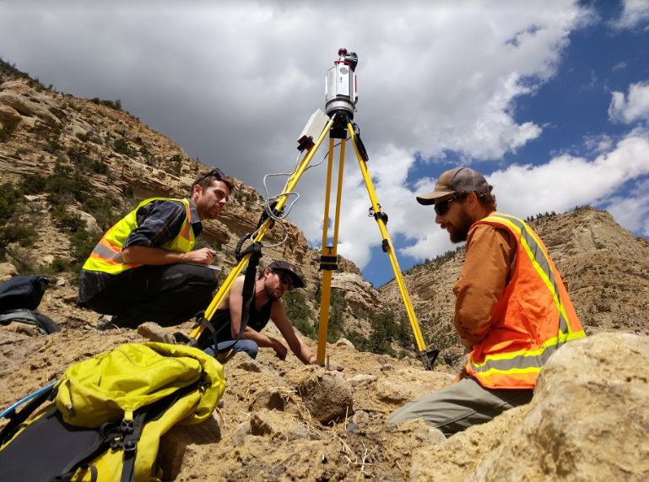

OSMRE geographer and Utah Division of Oil, Gas and Mining reclamation experts developing a 3D model of a mine reclamation project in Utah. [Photo credit: Carrie Middleton, OSMRE, 2018].

- TIPS Training Program: The TIPS Training Program is a collaborative effort among OSMRE, States, and Tribes. Course developers and instructors are reclamation experts who use TIPS software to solve a wide-range of complex permitting, enforcement and abandoned mine land problems. Although most of the TIPS tools are off-the-shelf applications, TIPS training is tailored exclusively to mining and reclamation uses. TIPS courses are delivered on-site at the customer’s request, and in training centers located in OSMRE’s Regional Offices: Denver, Colorado; Alton, Illinois; and Pittsburgh, Pennsylvania.
In FY 2018, the TIPS training program received a customer satisfaction rating of 98 percent, meeting the annual Government Performance and Results Act goal. Twenty instructor-led classes were held in FY 2018 with 234 students completing class sessions. Additionally, twenty-six students attended two online self-study training classes sponsored by TIPS, bringing the FY 2018 total to 260 students. Three of the 20 on-site training classes were conducted at state office locations to meet the specific training needs of particular groups of students throughout the SMCRA community.
While many TIPS courses are facilitated by an instructor in a traditional classroom, the TIPS Training Program continues to actively expand online opportunities and provide “just-in-time” training resources for its customers. Over 100 online courses are available on DOI Talent and ESRI for Geographic Information System modeling and mapping. TIPS utilizes the DOI Talent eLearning environment and continues to educate instructors on eLearning techniques for online instruction.

National Technical Training Program (NTTP). Established in 1985, NTTP is an ongoing training program designed to aid the bureau’s mission by increasing the technical competence and professionalism of State, Tribal and OSMRE regulatory and reclamation staff. The NTTP provides comprehensive training in the skills needed to carry out the mandates of SMCRA. The entire program, from identification of training needs through course development and presentation, is a cooperative effort between State, Tribal, and OSMRE offices. The NTTP utilized 160 subject matter expert instructors (mostly volunteers) from State, Tribal, and OSMRE offices in FY 2018, to teach classes. The instructors are experts in mining regulatory and reclamation practices who keep abreast of changing technologies, evolving methodologies, and policies to ensure the training reflects the best protection and land restoration practices.

In FY 2018, NTTP trained 873 students from State, Tribal and OSMRE programs. It offered 39 training sessions covering technical, legal, and programmatic subjects ranging from best practices and technologies to protect society and the environment from the adverse effects of surface and underground mining to methods to restore land use capabilities. The course subjects are, where possible, tailored to conditions and characteristics specific to each mining region, and offered in or near those regions. Course subjects include a wide variety of technical areas for a variety of practical applications including the design of abandoned mine land restoration, proper inspection tools and techniques, soils and revegetation, identification and handling of acid/toxic forming materials, water quality assessment, legal aspects of enforcement procedures, and preparation of evidence and testimony. In FY 2018, the program achieved an overall effectiveness rating of 90 percent, based on student and supervisor responses regarding the value of the training in their current positions.

National Technology Transfer Team (NTTT). The OSMRE NTTT brings together members of OSMRE, State, and Tribal SMCRA programs, as well as representatives from the Interstate Mining Compact Commission, and the National Association of Abandoned Mine Land Programs in order to coordinate understanding of mining related issues across the country. The team manages and promotes the Applied Science Program, whose goal is to develop and demonstrate improved technologies to address environmental issues related to the mining of coal, and subsequent reclamation of the land. The program has accomplished this by funding studies by universities, non-profit organizations, and SMCRA Regulatory Authorities covering topics such as coal mine reclamation, revegetation, blasting, hydrology, coal mine voids and fires, soil productivity, acid mine drainage, and other topics relevant to environmentally responsible mining and reclamation. The Applied Science Program had 20 ongoing projects at the beginning of FY 2018, of which one was completed during that fiscal year. Three Technical Investigations funded in FY 2015 have been completed; the remaining four are on track to be completed in FY 2019. Twelve Applied Science projects funded in FY 2016 are on track to be completed in FY 2019. Reports on these projects and investigations are available at https://www.osmre.gov/programs/tdt/appliedscience/projects.shtm.

Another program that OSMRE utilizes to award cooperative agreements is the Acid Drainage Technology Initiative (ADTI) created in 1995 and renamed the Mine Drainage Technology Initiative (MDTI) in FY 2017, to reflect the need to address mine drainage (MD) issues beyond acidity. The guiding principle of the initiative was to build consensus among industry, federal, and state regulatory agencies on acidic and toxic drainage technology development and technology transfer issues. MDTI cooperative agreements provide a forum for collaboration and information exchange with the following goals: (1) Develop an understanding of MD so as to better predict, avoid, monitor, and remediate MD; (2) Develop innovative solutions to MD water-quality problems; (3) Identify, evaluate, and develop “best science” practices to predict MD prior to mining; and (4) Identify successful remediation practices for existing MD sources and describe the best preventative technologies. For our most recent award, OSMRE entered into a 2-year cooperative agreement with Iowa State University in FY 2018.

The team also hosts and participates in technology transfer activities such as workshops, forums, and symposia, in order to collaborate with partners outside the SMCRA community. This aspect of the team’s activities is currently being expanded to take advantage of newer web-based options, such as webinars, YouTube, and social media including Twitter, Facebook, Instagram, and Snapchat. In addition, the team has created an interactive map on its webpage by which interested parties can access information on completed projects by selecting the location of the institution that conducted the project work. The map can be accessed at https://www.osmre.gov/programs/tdt/appliedScience.shtm.

VIII. National Park Service

As part of its mission, the National Park Service (NPS) actively manages the natural, cultural and historical resources entrusted to it. This management includes preserving and maintaining these resources and, where necessary, preventing impairment, mitigating adverse impacts, or restoring these resources. The vast majority of these activities are undertaken at the level of each individual park unit, but service-wide networks, programs, and centers make related scientific contributions in areas, such as inventory and monitoring, and preservation technology.

Scientific activities within the NPS focus on improving the understanding and management of park natural and cultural resources. In cooperation with partners, the NPS also works to preserve and interpret similar resources outside parks. The information generated by these activities is shared with park managers and stakeholders, including public and private land managers, as well as the broader public, largely through interpretive programs, exhibits, conferences, meetings, training, and standard publication media such as reports, newspapers, journals, magazines, fact sheets, and webpage postings.

In order to expand the range of expertise and tools available to it, the NPS participates in many collaborative ventures with universities and other governmental and non-governmental organizations, including the Cooperative Ecosystem Studies Unit Network.

The NPS Cultural Programs include the National Center for Preservation Technology and Training (NCPTT), which was created by Congress to fill a fundamental need for research and technology transfer among Federal, State, and local historic preservation programs. The NCPTT serves as a research and development laboratory for historic preservation and advances the application of science and technology to preservation problems. The NCPTT also supports applied research, partners with professional and scientific organizations, publishes technical guidance for preservation professionals, and trains students and practitioners in the latest preservation techniques.

The NPS also encourages qualified scientists to undertake research on parks’ physical, biological, and other resources under the aegis of park Scientific Research and Collecting Permits and other permits. Such permits are issued for scientific and educational purposes only. The collected specimens and other materials and components of such specimens and materials may not be used for commercial or other revenue-generating purposes. Parties proposing commercial use of research results must enter into an agreement to share benefits with the NPS or an agreement in which the NPS explicitly declines to share benefits. In accordance with the National Parks Omnibus Management Act of 1998, which authorizes the Secretary of the Interior to enter into negotiations with the research community and private industry for equitable, efficient benefits-sharing arrangements, the NPS has developed policies and procedures to implement benefits sharing. For each benefits-sharing agreement, the NPS proposes to choose an applicable agreement type from among several available authorities. The CRADA, authorized by the FTTA, is one such option. For further information on NPS benefits sharing, see: http://www.nps.gov/applications/npspolicy/DOrders.cfm.

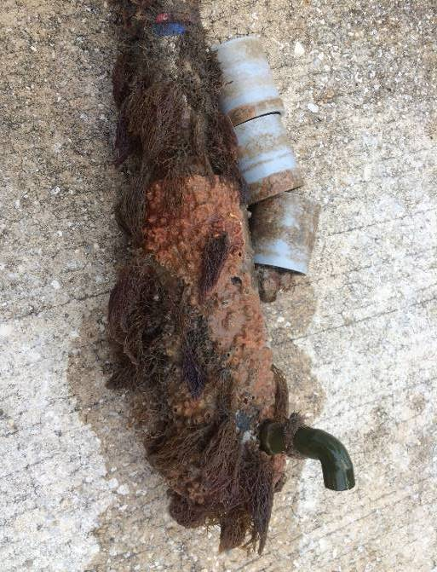
Device to Facilitate Water Quality Measurement in High Biofouling Environments. The Gulf Coast Inventory and Monitoring Network, one of 32 NPS Inventory & Monitoring Networks, has a CRADA with In-Situ, Inc., to develop and test an NPS employee’s invention and evaluate its potential for commercial manufacture and sale. The device enables currently available datasondes, which are used to measure water quality, to greatly increase the length of unmanned or continuous monitoring deployments in biofouling environments. It may also increase accuracy under turbulent flow conditions. The device modifies the calibration chamber of the sondes so that instrument/sensor drift rather than water quality conditions drives recalibration frequency requirements.

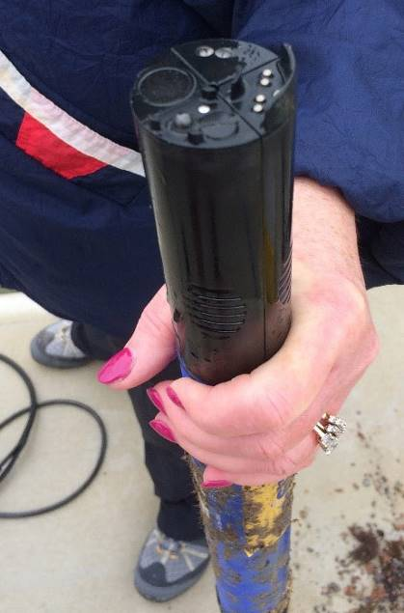
In FY 2018, the Gulf Coast Inventory and Monitoring Network continued operating two of the modified instruments at Padre Island National Seashore (PAIS). Since the invention was deployed at PAIS, the Network has reduced the cost of maintenance and repair of the instruments by over 50%. The goal is to make the invention available on the open market so others can benefit from using the device.
This trial at Cumberland Island National Seashore, one of five trials in different high-fouling environments, showed that the invention can eliminate biofouling in a warm water, high biofouling marine environment. LEFT: The invention connected to an In-Situ AT600 datasonde prior to deployment. CENTER: Modified datasonde removed from the water after a six-month deployment. RIGHT: The internal sensors of the same modified datasonde at the end of the trial. While the six-month exposure to the environment resulted in extreme barnacle growth, the sensors remained clean and functioning within normal ranges. [Photo credit: Joe Meiman, NPS, 2017].
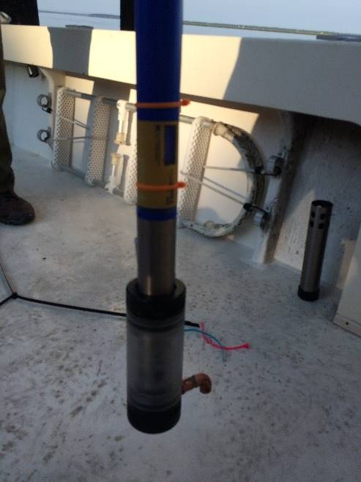
Benefits-Sharing Agreement. Yellowstone National Park executed a non-traditional CRADA with a small business that plans to commercialize research results from a study of microbial mats collected from thermal areas in the park. The company is providing non-monetary benefits related to a genetic monitoring program for the purpose of conserving genetic diversity within the park. The company will provide monetary benefits upon successful commercialization of its discoveries.

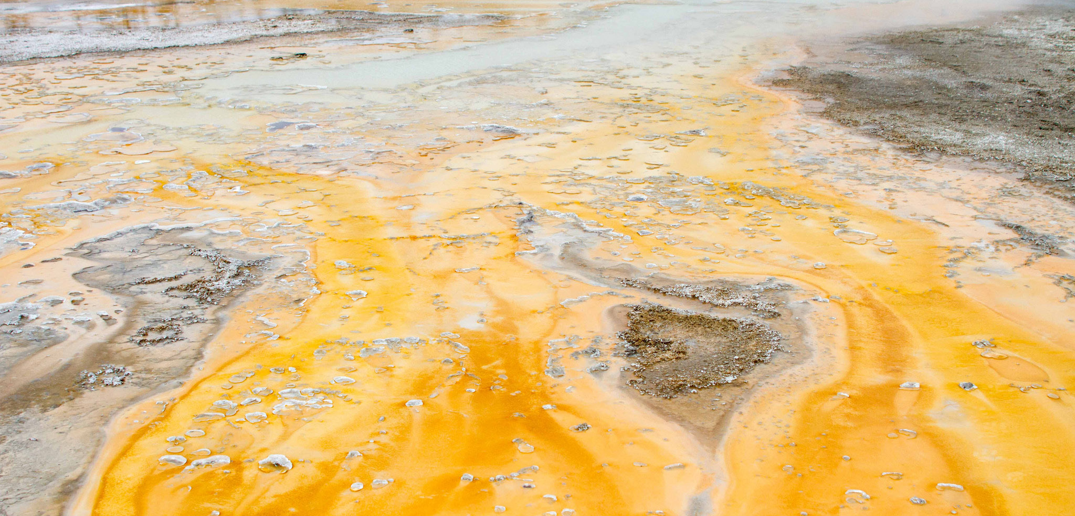

Doublet Pool, Yellowstone National Park. Research on microorganisms found in extreme environments, such as this thermal feature, has led to some significant discoveries and practical applications. [Photo credit: NPS/Yellowstone National Park]

IX. Bureau of Reclamation

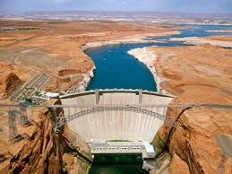
The Bureau of Reclamation (Reclamation) is a water management agency whose mission is to manage, develop, and protect water and related resources in an environmentally and economically sound manner in the interest of the American public. Reclamation is the largest supplier and manager of water in the 17 western States and the Nation’s second largest producer of hydroelectric power. Reclamation manages water for agricultural, municipal and industrial uses, and provides flood risk reduction and recreation for millions of people.
Glen Canyon Dam, Upper Colorado [Photo credit: Lori Keith.]

According to the Department of the Interior’s Economic Report Fiscal Year 2017, Reclamation’s activities, including recreation, contribute over $63.5 billion to the economy and support 460,000 jobs. Reclamation owns 76 power plants and operates and maintains 53 of those plants. The 53 hydroelectric power plants account for 19 percent of the hydroelectric generating capacity in the United States. Annually, Reclamation generates 44 billion kilowatt hours of electricity, enough to supply over 3.4 million U.S. households and collects over $1 billion in gross power revenues for the Federal government.

Reclamation R&D – Reclamation’s R&D is primarily focused on applications to identify and develop solutions related to the broad spectrum of water and hydropower-related issues. Reclamation’s Research and Development Office manages two appropriated R&D programs, the Science and Technology (S&T) Program and the Desalination and Water Purification Research (DWPR). The S&T Program is the primary R&D program for Reclamation and funds intramural research that spans the spectrum of water and water-related resources challenges. The program also enlists crowd-sourced innovation via technology prize competitions addressing some of Reclamation’s most difficult challenges in infrastructure, water availability, and environmental compliance. S&T Program goals are to identify and develop cost-effective solutions to the technical and scientific problems affecting the accomplishment of Reclamation’s mission and to communicate those solutions to Reclamation offices, its stakeholders, other water and power management officials, and the general public. The DWPR Program invests in extramural R&D that advances the capabilities of water treatment technologies to enable them to be used more broadly for the creation of new water supplies. Such new supplies can relieve water stress on Western communities, Tribes, Western river basins supporting Reclamation projects, and the Nation as a whole. The program also supports operation and maintenance of the Brackish Groundwater National Desalination Research Facility, which hosts federal and non-federal R&D clients conducting bench-scale studies to pilot-scale demonstrations.

Reclamation Technology Transfer – Although Reclamation’s R&D focuses on water and power issues specific to the arid and variable climates characteristic of the Western U.S., the new solutions, tools, and information developed can have broad applicability regardless of location or jurisdiction. The transfer of Reclamation’s technology and knowledge across the national and international communities of practice maximizes public benefits of Reclamation’s R&D investments.

The majority of Reclamation’s technology advancements are transferred through public dissemination via the R&D office website (www.usbr.gov/research), while others require the capabilities and know-how of the private sector to mature, mass produce and otherwise commercialize the technology into market-ready products. Reclamation’s research nexus with industry is typically in the area of hydroelectric power generation, water infrastructure, water conservation, and desalination/water purification technologies. Reclamation’s R&D Office produced over 50 research reports in FY 2018.

If an industry partner is needed to ultimately transfer the technology into a market-ready product, Reclamation utilizes the authorities available under Federal technology transfer legislation to protect intellectual property, as needed, and form research and licensing partnerships with U.S. manufacturing industries. Reclamation’s R&D Office implements these authorities on behalf of the bureau, and serves as the Bureau’s Office of Research and Technology Applications (ORTA), as required by 15 U.S.C. § 3710(b).

Reclamation also works to increase awareness across U.S. industries and other non-governmental organizations of the specialized research resources (people, lands, and facilities) that they can access through technology transfer agreements authorized by 15 U.S.C. § 3710a. In addition to physical research laboratories, Reclamation’s R&D assets include engineering and scientific expertise, extensive water storage, water delivery, and hydropower facilities that offer unsurpassed real-world laboratories for field tests, evaluations, and demonstrations of new technologies and processes related to water and hydropower. Although the majority of its R&D activities do not involve the development of patents or industry involvement to mature technologies into viable products, the technology transfer activities that Reclamation conducts under the authorities of the Federal technology transfer legislation are an important subset of its technology transfer responsibilities.

Highlights of activities conducted under the Federal Technology Transfer Act during FY 2018 include the following:

Explore New Ways to Increase Impact for Reclamation’s Water Treatment Technologies. Reclamation has entered into a contract with Hyperion Technologies that runs the Fed Tech Program, to explore contemporary ways to secure technical and licensing partnerships for its patented or patent pending water treatment technologies. Fed Tech is a Washington, DC, based startup accelerator managed by Hyperion Technologies that works with over 30 federal labs and universities around the country. Fed Tech will pair Reclamation’s water treatment technologies with a diverse entrepreneur and mentor team experienced in this technical area. The program will then lead this team through over two months of customer discovery and market validation exercises that will kick off in 2019.

Reclamation has several patented and patent pending water treatment technologies that are seeking partners to mature and commercialize. These reverse osmosis polyamide membrane technologies (Patent Nos. 7,806,275, 9,056,284 and pending Patent Serial No. 14/857,679) are used to desalinate and purify seawater, wastewater, and surface water. Chlorine is used in the reverse osmosis process to prevent biofouling of the membrane; however, chlorine rapidly degrades polyamide membranes. This new polyamide membrane chemical formulations are resistant to chlorine degradation which increases the life of the membrane and can lower replacement costs for desalting plants. Reclamation is seeking partners to develop or mature and commercialize these new polyamide membranes that meet or exceed the current industry standard for water purification performance characteristics while not deteriorating from chlorine exposure.

Reclamation’s access to the Fed Tech Program, which offers unique ways via market validation exercises, training and mentoring, would provide a greater chance of broader dissemination of government-funded products. The Fed Tech Program’s service is key for Reclamation inventors who have technical expertise on their invention but may lack expertise in commercialization or business practices to get their inventions adopted and disseminated in the marketplace. Under Reclamation’s arrangement with the Fed Tech Program, Reclamation inventors would provide the technical expertise and the latter would provide the business and commercialization know-how, including a go-to market strategy for the technology, lessons learned video, and the establishment of strategic partners in the United States and or internationally.

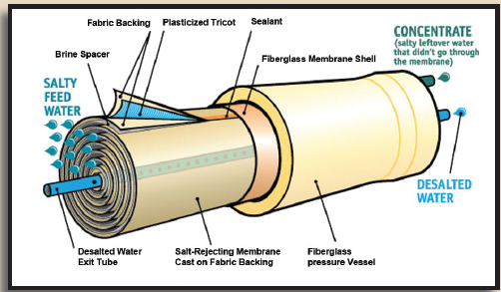
Schematic of a Reverse Osmosis Element inside a Pressure Vessel. Photo credit: Reclamation.

Test New Mussels Resistant Coatings for Reclamation Infrastructure. Reclamation conducts research across a broad portfolio of technologies for corrosion protection and methods to reduce fouling of infrastructure by mussels. This includes research into durable, “foul-release” coatings that would negate mussels’ ability to attach to the infrastructure. Reclamation’s Materials and Corrosion Laboratory (MCL) entered into a material transfer agreement to test new protective coatings that contain super hydrophobic additives for corrosion protection capabilities in coatings applications.

Reclamation’s MCL conducted a side-by-side laboratory comparison with and without a superhydrophobic additive in different coating systems to determine if there is any benefit in corrosion protection. The results showed improvement in corrosion protection for cyclic exposure while some mechanical and appearance properties decreased compared to the parent system. The only logical use for this new superhydrophobic additives would be for atmospheric exposure but would have some obstacles to overcome.

The testing results were shared with the company who provided their protected super hydrophobic additives while gaining a better understanding of possible new market applications for their technology. Testing this new additive allowed Reclamation to continue to gain knowledge and develop new and better coatings for its water infrastructure.

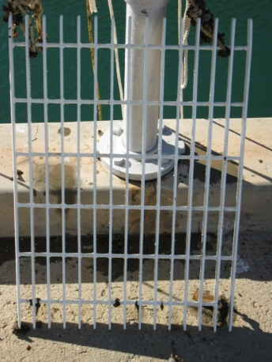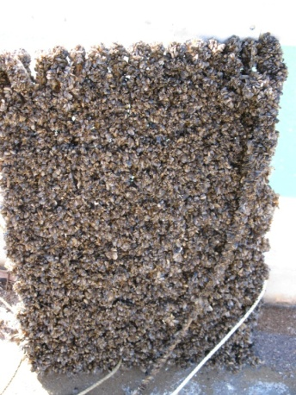

Examples of biofouling by mussels’ attachment to Reclamation’s infrastructure. Left: Pipe clogged with mussels. Center: A clean steel control grating without mussel attachment. Right: The steel control grating with mussel attachment. Photo credits: Reclamation

X. Bureau of Safety and Environmental Enforcement
The Bureau of Safety and Environmental Enforcement (BSEE) works to promote safety, protect the environment, and conserve resources offshore through vigorous regulatory oversight and enforcement. BSEE’s R&D focus is on offshore operational oil, gas, and renewable energy issues.
Within BSEE, the Office of Offshore Regulatory Programs (OORP) develops standards and regulations to enhance operational safety and environmental protection for the exploration, development, and production of offshore oil and natural gas on the U.S. Outer Continental Shelf (OCS). OORP conducts standards research, inspection policy evaluations, technology risk analysis, and data interpretations to manage compliance programs governing oil, gas, and mineral operations on the OCS.
The Oil Spill Preparedness Division (OSPD) is responsible for developing standards and guidelines to ensure that offshore operators are prepared to respond to an oil spill. It also ensures their Oil Spill Response Plans comply with regulatory requirements. OSPD plays a critical role in the review and creation of policy, guidance, direction, and oversight of activities related to the agency’s role in ensuring the industry’s preparedness for oil spill response. The Division oversees the Oil Spill Response Research (OSRR) program and works closely with sister agencies, such as the U.S. Coast Guard, the National Oceanic and Atmospheric Administration, and Environmental Protection Agency to continually enhance response technologies and capabilities.
BSEE R&D programs operate through OORP’s Emerging Technologies Branch (ETB), and OSPD’s Response Research Branch (RRB). The ETB, established in 2012 to replace the Technology Assessment and Research (TA&R) group, is the agency’s focal point on operational safety and pollution prevention research. It also helps ensure that industry’s OCS operations incorporate the use of Best Available and Safest Technologies (BAST), as required in the 1978 Outer Continental Shelf Lands Act amendments. OSPD’s Oil Spill Response Research (OSRR) program was established through the Oil Pollution Act of 1990 to research oil spill response technologies and operational techniques. OSPD also operates the Ohmsett Facility in Leonardo, NJ, which serves as the National Oil Spill Response Research and Renewable Energy Test Facility. The Ohmsett facility is available to provide independent and objective performance testing of full-scale oil spill response equipment and marine renewable energy devices. Additionally, the facility is available to help improve existing technologies through research and development.
The majority of BSEE’s technology advances are transferred through public dissemination. In addition to making the final reports of research projects publicly available on its website, BSEE also makes its research results available via conferences such as the annual Clean Gulf Conference, and other fora, such as the Pacific States-British Columbia Oil Spill Task Force Annual Meeting and the Ocean Energy Safety Institute’s Public Research Forum.
BSEE’s primary research synergy is with state, federal, and international government organizations; the oil/gas and renewable energy industries; and oil spill removal organizations. It is typically in the area of ensuring that the best available and safest technology is used on the US OCS and the best available science is utilized in regulatory decision making. Additional information and research deliverables are available at https://www.bsee.gov/what-we-do/research/tap and https://www.bsee.gov/what-we-do/oil-spill-preparedness/oil-spill-response-research.
BSEE is a member of the International Committee on Regulatory Authority Research and Development (ICRARD), which focuses on transferring knowledge worldwide between governmental entities in the area of health, safety, and environment in the petroleum sector. Although membership is only available to government entities, ICRARD cooperates with industry to coordinate and transfer technology.
BSEE is also a member of the Interagency Coordinating Committee on Oil Pollution Research (ICCOPR). Comprised of 15 Federal agencies, ICCOPR was established as part of the Oil Pollution Act of 1990 to “coordinate a comprehensive program of oil pollution research, technology development, and demonstration among the Federal agencies, in cooperation and coordination with industry, universities, research institutions, state governments, and other nations, as appropriate.”
BSEE is a member of the International Regulators’ Forum (IRF). This organization consists of ten member international countries whose goal it is to provide leadership on safety and safety-related regulatory matters for offshore oil and gas activities. Other members include Norway, Canada, Brazil, and the U.K.
The following are examples of FY 2018 completed or ongoing research projects that would, among other things, advance technological options and transfer knowledge about best technological practices to industries and regulators operating on the OCS.
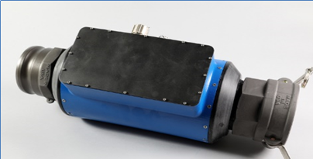
Development of a Recovery Efficiency (RE) Sensor: This project developed a prototype to measure the percentage of oil and water in a fluid as it flows through the sensor. Oil Spill responders currently do not have a method for knowing in real time how much water they are collecting along with oil. This tool will allow responders to adjust their response methods to maximize oil storage and minimize water storage, leading to a more efficient response operation. The sensor, developed by Battelle Memorial Institute, utilizes both capacitance measurements to measure oil concentrations of 60-70% or greater, and eddy currents, used to measure low oil concentrations. It was tested at Ohmsett in June 2018 with multiple oils and salinities. Average measurement error was 6% which met the stated requirement. It is anticipated that this sensor will be further developed in a Phase II FY19 project.
Recovery Efficiency Sensor [Photo credit: Battelle Memorial Institute].

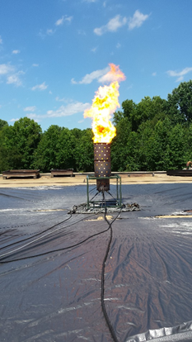
Development of a Low-Emission Spray Combustor for Emulsified Crude Oil: When petroleum spills on an open body of water, it is exposed to a number of natural processes that transform the oil, including emulsification where wind and wave action incorporates droplets of water into the oil dramatically increasing the volume and increasing its viscosity. The objective of this project is to develop a novel approach for oil spill and recovery using a flow blurring atomizer to cleanly and efficiently burn crude oil emulsions. A sub-scale burner at 25% of full-scale and an engineering scale burner at 50% of full-scale with the flow blurring atomizers were built, and tests were successfully performed using crude oil emulsified with up to 60% water. Recirculation zones within the unit created by a shroud reflect radiant heat from the flame and shroud back to the plume to further evaporate atomized droplets of oil making them available for combustion. The outcomes of these initial tests will inform the design of a full-scale burner that can be deployed in open waters. A listening session with industry to determine system integration needs was held at the BSEE New Orleans, Louisiana offices.
The prototype combustor is cleanly burning 25% water-in-oil emulsions mixed with air at the Naval Research Lab’s Chesapeake Bay Detachment in Maryland. [Photo credit: BSEE].
Characterizing the Behavior of Inconel Clad A387 Steel in High-Pressure High-Temperature, Corrosive Environment: High-Pressure High-Temperature (HPHT) O&G reservoirs are inherently more challenging for materials and equipment than conventional reservoirs. Equipment made of high-strength ferrous alloys has been found to be susceptible to hydrogen embrittlement and stress corrosion cracking under HPHT corrosive conditions. To combat this challenge, the industry uses corrosion-resistant alloys clad to the surfaces of ferrous components when in contact with HPHT sour-gas conditions. While providing corrosion resistance, the impact to the fatigue and fracture properties of these clad materials has not been well documented in the open literature. This study was funded by BSEE to generate fatigue and fracture data for Inconel 625 clad ASTM A387 Grade 22, Class 2 steel, a cladding material commonly used in deep-water oil and gas equipment. The study measured properties such as fracture toughness, and crack growth rate and fatigue under a cyclic stress test in HPHT sour-gas conditions.
Microstructure images of the weld-interface of clad layers. The distinct differences in layer microstructure can be seen. (Photo: BSEE)

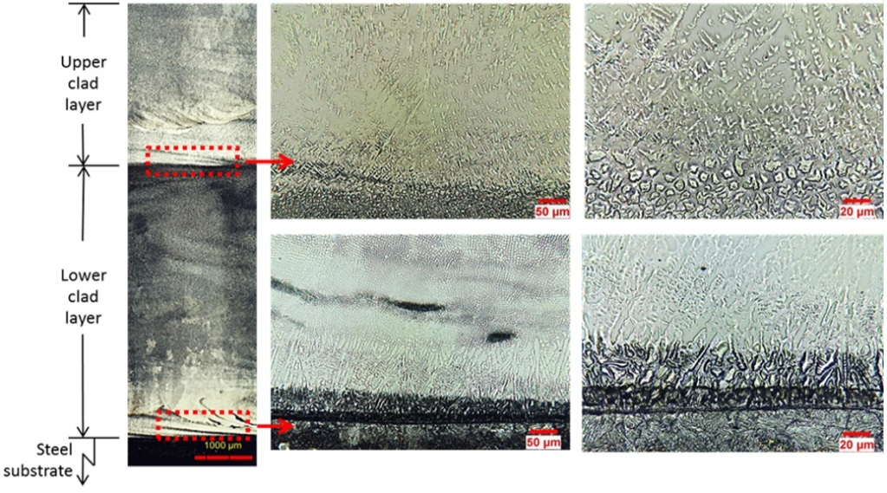
The data and mathematical material models/equations provided by this study can serve as a basis for establishing a broad collection of publicly available fatigue and fracture data for use by designers, failure analysts and by BSEE for evaluating clad components subjected to HPHT sour-gas conditions. The study’s results suggest that any crack that starts in the exterior of a cladded component may accelerate its growth rate once the outer clad layer has been completely penetrated and the crack grows into the lower clad layer. The measured values and the mathematical models are useful for numerical simulations of fatigue and fracture as well as for estimating component life to determine critical issues that lead to failures. The resulting mathematical models were summarized in a database, as a repository for the data generated in the current project as well as any data offered by the industry or developed in future efforts. Results can be used to develop a predictive computer-modeling tool for use in analyzing failure modes of cladded materials used in oil and gas drilling and equipment.

Study of Tension Leg Platforms (TLPs): The Gulf of Mexico is home to approximately 46 deep-water floating structures, of which 16 are tension leg platforms (TLPs). Of the 16 TLPs, 4 are approaching the end of design life and entering life extension discussions with BSEE. Industry is currently writing guidance for integrity management and therefore provides BSEE the opportunity to align its methodology with industry in an effort to better regulate the inspection, reporting, and maintenance of these TLPs.
TLP Components. Figure credit: BSEE.
The objective of this study was to make recommendations by which BSEE can evaluate current industry inspection processes, reporting, and monitoring system methods and help develop a plan of action concerning four critical areas of focus: tendon integrity management, tendon life extension, fatigue of tendon components that may be relatively inaccessible because of placement, and understanding such “uninspectable” tendon components. The study provided a number of recommendations to develop and help focus on BSEE’s inspection program.

XI. Bureau of Ocean Energy Management

The Bureau of Ocean Energy Management (BOEM) manages the Nation’s offshore energy and mineral resources in an environmentally and economically responsible way. It ensures access to and the fair return for conventional and renewable energy and mineral resources of the U.S. Outer Continental Shelf (OCS) to help meet the energy demands and mineral needs of the Nation while also balancing such access with the protection of the human, marine, and coastal environments.

As the Nation’s offshore energy and mineral resource manager, BOEM is committed to using the best available science across a range of relevant disciplines that provide the scientific and technical foundation and the human capital needed to make sound decisions at all levels of the organization. Management of the energy and mineral resources of the OCS is governed by the Outer Continental Shelf Lands Act, which establishes procedures for leasing, exploration, and development and production of those resources, including oil, gas, offshore renewable energy, and marine minerals such as sand and gravel used for coastal restoration projects.

BOEM’s Office of Environmental Programs (http://www.boem.gov/Environmental-Stewardship/) conducts environmental reviews, including the National Environmental Policy Act (NEPA) analyses and compliance documents for each major stage of energy development and planning. These analyses inform BOEM’s decisions on its National OCS Oil and Gas Leasing Program as well as a variety of other conventional and renewable energy leasing and development activities. Additionally, BOEM’s scientists conduct and oversee environmental studies to help make the best policy decisions relating to the management of energy and marine mineral resources on the OCS through its Environmental Studies Program (ESP).

BOEM’s three regional offices, strategically located in New Orleans, Louisiana, Camarillo, California, and Anchorage, Alaska, manage oil and gas resource evaluations, environmental studies and assessments, leasing activities, including the review of plans for exploration, development and production, fair market value determinations, and geological and geophysical permitting.

BOEM Environmental Studies Program
BOEM’s Environmental Studies Program strives to apply the best science available for informed decision-making. It plans, conducts and oversees world-class scientific research to inform policy decisions regarding leasing and developing OCS energy and mineral resources. BOEM works to manage the exploration and development of the Nation’s offshore resources in a way that appropriately balances economic growth, energy development, and environmental protection through oil and gas leases, renewable energy development, and environmental reviews and studies. BOEM’s environmental studies cover a broad range of disciplines including archaeological resource protection, physical oceanography, meteorology, and air sciences, biology, protected species, social sciences and economics, submerged cultural resources evaluation, and the overall environmental effects of energy development. BOEM continues to be a leading contributor to the growing body of scientific knowledge about the Nation’s marine and coastal environment.

BOEM oversees scientific research conducted through contracts, partnerships with other governmental bureaus, cooperative agreements with State institutions or universities and interagency agreements. These arrangements enable the Bureau to leverage resources, meet national priorities and satisfy common needs for robust scientific information. Many of the Bureau’s studies are collaborations with partners under the umbrella of the National Oceanographic Partnership Program.

BOEM Technology Transfer
BOEM’s technology transfer activities include disseminating information, knowledge, and technologies to the various regions, and to commercial entities and other stakeholders with interests in the OCS. Virtually all these activities are undertaken using authorities provided to the BOEM other than the Federal Technology Transfer Act of 1986 (FTTA). Studies undertaken by or through funding from BOEM are available to the public through the Environmental Studies Program Information System (ESPIS) that summarizes more than 1,800 ongoing and completed BOEM-sponsored environmental research projects and provides online access to more than 3,600 research reports (http://www.boem.gov/studies). In 2018, ESP completed 42 studies that accounted for approximately $50 million dollars in BOEM-funded ocean research.

BOEM also partners with BSEE to select and fund research into renewable energy to facilitate industry development, and promote operational safety and pollution prevention through BSEE’s Technology Assessment Program. More information on this research is available at https://www.boem.gov/Technology-Assessment/.

Many large interdisciplinary projects with funding from BOEM have included partnerships with other Federal agencies and academic institutions as well as private companies directed towards offshore ecosystem studies that utilize state-of-the-art technologies such as autonomous underwater vehicle surveys, deep-water human-occupied submersibles, and remotely operated vehicles. Many projects have developed innovative imaging technologies and digital analysis techniques for establishing long-term biological monitoring stations in deep water. These partnership studies have leveraged expertise and technologies to meet common management goals.

Following are a few examples of BOEM’s ongoing scientific research and development activities, including some conducted in cooperation with other parties.

Developing the Next Generation of Animal Telemetry: BOEM’s Office of Environmental Programs (OEP) is working with NASA to advance the ability to monitor animal movements by leveraging NASA’s network of small satellites. Effective research and monitoring require an understanding of where animals go and what they do when they go to a particular place; this is accomplished through various types of telemetry. Wildlife telemetry is a critical tool both within and external to, the federal government. However, there are limitations to today’s animal telemetry technology, including lack of sufficient satellite vendors, data costs and limited spatial coverage. By partnering with NASA, BOEM is working to reduce these limitations and facilitate a common communications network for space-based monitoring, improving data accessibility and cost efficiency for energy development across public and private sectors. The study kicked off in 2018.

Spatial and Acoustic Ecology of Pelagic Megavertebrates: BOEM’s OEP has engaged in a Cooperative Agreement via a CESU partner, the University of North Carolina at Wilmington, to better understand the sightings, movement, and acoustic behavior of understudied marine mammals. A component of this project is improving BOEM’s ability to receive data from ocean users and disseminate important information to industry. This network, tentatively known as OceanSmart, will involve a partnership with industry to disseminate and receive spatial data paving the way for improved situational awareness for regulatory compliance. This study also kicked off in 2018.
Ecological Baselines Studies: BOEM uses state-of-the-art aerial imaging and acoustic methodology to monitor protected marine life across its regions. An IDIQ (indefinite delivery/indefinite quantity) contract was issued to Biodiversity Research Institute; LGL Ecological Associates, Inc.; and Normandeau, Inc. to provide critical data to improve the understanding of current distributions of seabirds, marine mammals, and turtles on the OCS. The multi-season aerial-digital surveys will help determine the distribution and abundance of seabirds, marine mammals and sea turtles from the Virginia-North Carolina border to the South Carolina-Georgia border and from the federal-state boundary (3 nautical miles) to a depth of 30 meters. The first surveys (for winter and spring, 2018) were completed in FY 2018.
Deepwater Atlantic Habitats: Building upon the previous award-winning paradigm for deepwater research established by studies in the Gulf of Mexico and Atlantic, this study will continue BOEM’s partnership with NOAA’s Office of Exploration and Research and the USGS, under the auspices of the National Ocean Partnership Program (NOPP), and direct interaction with the NOAA Deep Sea Coral Research and Technology Program (DSCRTP). Potential geographic regions of interest include several unexplored canyon systems offshore of North Carolina as well as unmapped portions of the Blake Plateau. A broad range of interdisciplinary methods will be employed to sample and characterize selected coral and chemosynthetic communities and benthic-pelagic environmental conditions. High resolution, ship-based mapping technologies will delineate substrate types and document the distribution of hard bottom areas. Sophisticated submergence facilities (e.g., Remotely Operated Vehicles, Autonomous Underwater Vehicles) will provide additional seafloor imagery and enable collection of seafloor samples and environmental parameters. Collected data will be analyzed using appropriate laboratory materials/protocols and software systems in order to describe community composition, complexity, and sensitivity to impacts.
As part of these studies, the DEEP SEARCH science team aboard the research ship Alvin, a human occupied vehicle, or HOV, conducted two dives in an area approximately 160 miles southeast of Charleston, S.C. It observed extensive reefs composed of the deep-sea stony coral, Lophelia pertusa. The team estimated that there were approximately 85 linear miles of discontinuous Lophelia reef at that location. The coral structures create complex habitats that are homes to diverse communities of invertebrates and fishes, making the reefs hotspots of biodiversity in the deep sea. Additional information on this significant discovery is available at: https://www.boem.gov/BOEM-and-Partners-Resume-Atlantic-Research/.
The team will spend the coming months and years fully characterizing the significance of these two dives and the extent and makeup of the reefs.

XII. Bureau of Land Management

The Bureau of Land Management (BLM) manages approximately 245 million surface acres and 700 million sub-surface acres, which amounts to more than 1-in-10 acres of the surface land and about 1-in-3 acres of the subsurface land in the United States. The BLM’s multiple-use and sustained yield mandate, set forth in the Federal Land Policy and Management Act of 1976, directs the management of America’s public land resources for a variety of uses, such as, energy and minerals development, livestock grazing, recreation, and timber harvesting, while also protecting a wide array of natural, cultural, and historical resources for the use and enjoyment of present and future generations. The BLM works with partners to promote multiple uses of those lands through shared conservation stewardship and facilitates opportunities for energy development that create jobs, help support local communities, and establish America’s energy dominance.

In FY 2017, the latest year for which data has been compiled, the diverse activities authorized on BLM-managed lands generated $96 billion in economic output throughout the country—more than any other agency within the Department of the Interior. This economic activity in FY 2017 supported an estimated 468,000 jobs and also provided $41 billion in direct—and $54 billion in indirect— contributions to the U.S. economy. This activity also resulted in substantial revenue to the U.S. Treasury and state governments, mostly through royalties on minerals.

The BLM regularly gathers, maintains, and publishes various types of data to inform stakeholders and the general public about its stewardship responsibilities. This data includes detailed information on the commercial uses of the public lands (such as energy development, livestock grazing, mining, and timber harvesting); recreational activities; revenues from these activities; wild horse and burro management, including figures relating to on-range herd populations, removals from the range, and national adoption figures; cadastral (mapping) surveys; rangeland resources and more than 870 special units, such as wilderness areas, that are part of the BLM’s 32 million-acre National Conservation Lands system; and the socio-economic impacts of public land management.

Examples of FY 2018 technology transfer activities include the following bureau-wide and program-specific efforts:
Maintaining and Publishing Quality Land Management Data: The BLM compiles, maintains and publishes approximately 20 sets of national data. These include the national Public Land Survey System (PLSS), and detailed information on BLM Administrative Unit Boundaries, Surface Management Agency, Grazing Allotments, and Wild Horse and Burro Herd Areas, among others. The PLSS data set is used, maintained and published in partnership with other federal agencies as well as tribal, state and local governments. The Western Governors’ Association (WGA) recognizes the published PLSS data set (also referred to as Cadastral National Spatial Data Infrastructure CadNSDI), land record modernization and cadastral data as “… critical for maintaining livable communities, encouraging economic development and developing tools that give community leaders the ability to manage both.” The states of Utah and Montana host PLSS data on their web sites for publication and distribution and the data is used by the Bureau of Census to standardize the mapping of state, county, and other jurisdictional boundaries. This PLSS data set also serves as the basis for automating the mapping of land transactions such as oil and gas leasing, permitting, timber sales and the withdrawal of lands for military use or preservation.
Increased Access to and Use of Data and Information: The BLM increased public access to data and information through a variety of technologies and applications, including the BLM’s Geographic Information System (GIS) Transformation Project, Landscape Approach Data Portal; BLM Navigator, a one-stop shop for keyword and geospatial search of BLM data; and the BLM Library. The BLM Library, located at the National Operations Center in Denver, exists to serve BLM employees and to assist members of the general public. It provides access to BLM’s extensive library catalog, publications, journals, databases, and subject guides. In FY 2018, the library website had 24,712 page views.
BLM provides data to government clearinghouses, such as data.gov, recreation.gov, and data.doi.gov. These tools make it easier for the public to view, explore and acquire data that the BLM uses to help manage public lands for multiple uses such as energy development, livestock grazing, recreation, and cultural resources.
The BLM is providing all of it's historic and newly acquired imagery to the public via USGS-EROS. To assist people in using this information, the BLM also initiated a learning outreach effort to BLM state and field offices regarding the use of Google Earth Engine for scientific resource management. Google Earth Engine is an online architecture allowing the processing, analysis, and derivation of management products from remotely sensed imagery and other geospatial information about BLM lands across the US. Additionally, BLM provided photogrammetric training for terrestrial and Unmanned Aerial Systems projects to a variety of constituencies including federal agencies, non-profit organizations, universities, and K-12 student groups. These classes focus on the proper capture, processing, analysis, and use of imagery for natural and cultural resource management.
Assessment, Inventory, and Monitoring (AIM): BLM’s Assessment, Inventory, and Monitoring (AIM) strategy provides a standardized process for the BLM to collect quantitative information on the status, condition, trend, amount, location, and spatial pattern of resources on the nation’s public lands. The BLM uses AIM data to make necessary management adjustments to meet resource management objectives described at project, activity plan, resource management plan, and national program levels.
The AIM approach is based on five key elements: 1) a standardized set of core and contingent indicators for both terrestrial and aquatic ecosystems, 2) an appropriate sampling design, 3) a structured implementation process, 4) electronic data capture, and 5) integration with remote sensing.

Core terrestrial and aquatic indicators were selected because they are known to be both ecologically relevant and clearly tied to rangeland health and state and federal clean water standards. It is important to note that not only are the indicators standardized, but the methods used to collect the data are also standardized. This means that the same data are collected in the same way at each sampled site. The use of standardized methods helps ensure that the AIM data are comparable.

AIM data is available through the public-facing versions of the Terrestrial AIM Database (TerrADat) and the Aquatic AIM Database (AquADat). Various state government agencies, such as the Nevada Department of Wildlife, Wyoming Game and Fish, and the Alaska Department of Environmental Conservation, are engaged in data collection that is compatible with AIM. AIM data is used by a wide variety of federal and state agencies, universities, non-governmental organizations, private industry, and the public.

A full-day AIM symposium occurred during Annual Meeting of the Society for Range Management held from January 28‒February 2, 2018. BLM state monitoring leads along with partners spoke about their AIM efforts and how it informs management decisions. Topics also included underpinning concepts of AIM such as maintaining information quality and integration with remote sensing.

BLM Partnered with other federal agencies (e.g., NPS, USFS, USFWS) and Utah State University to support the National Aquatic Monitoring Center (NAMC). NAMC encourages and fosters scientifically sound aquatic monitoring activities on public lands. NAMC’s primary foci are the use of aquatic macroinvertebrates as bioindicators of freshwater biological integrity under the Clean Water Act and the development of scientifically defensible aquatic monitoring and assessment tools. NAMC processed over 1,500 macroinvertebrate samples in FY 2018 for over a dozen state and federal agencies and supported web-based interfaces to publically serve all monitoring data. An example focus of NAMC is the identification of aquatic invasive invertebrates in efforts to document distributions and ultimately prevent their spread to uninhabited water bodies.

BLM’s National Conservation Lands: BLM’s National Conservation Lands division works with scientific partners and local communities to address BLM’s management-focused research needs. BLM encourages scientists to perform research on National Monuments and Conservation Areas and communicate their findings to the public. All research projects performed on BLM’s National Conservation Lands have a public outreach component including presentations, reports, and publications. In FY 2018, projects performed on National Conservation Lands with local partners included pollinator habitat studies, paleontological and archaeological resource inventories, wetland condition assessments, and rare species surveys.

Cultural Heritage and Paleontology: The BLM Cultural Heritage and Paleontology programs partner with museums, universities, and others to conduct research, inventory the public lands and learn about the location and significance of cultural and paleontological resources, manage important cultural and scientific collections of artifacts and specimens from the public lands, and share research results with the public and across research communities. In addition, BLM partners with state historic preservation offices, state geologic surveys, Indian tribes, museums, and universities, as appropriate, to facilitate research and better manage cultural and paleontological sites and locality information. The relationship is often reciprocal, with scientific data shared by BLM and partners. These partnerships address requirements of the National Historic Preservation Act of 1966, the Archaeological Resources Protection Act of 1979, and the Paleontological Resources Preservation Act of 2009.

In 2018, the BLM Cultural Heritage program issued a national data standard for cultural heritage data (IM-2018-079), providing a set of rules the BLM will follow to track and store GIS boundaries for cultural resource sites and investigations. A contractor was selected to stand-up the national database as part of the development of the National Cultural Resources Information Management System (NCRIMS). This system provides high-level cultural resource data to streamline and facilitate early stage planning and support emergency undertakings for both BLM and industry land users, as well as, disseminate broader scale cultural information for future research and modeling applications.

XIII. Conclusion

During FY 2018, the Department’s technology transfer activities included:
- Publishing over 10,500 reports, books, papers, fact sheets, and other publications.
- Engaging in 740 Cooperative Research & Development Agreements (CRADAs), and at least 249 other collaborative R&D relationships.
- Executing 687 non-traditional CRADAs, such as technical assistance, material use, and facility use agreements.
- Disclosing nine (9) new inventions, filed seven (7) new patents and received six (6) patents.
- Managing seventeen (17) active licenses for inventions and other intellectual property. Thirteen (13) of these were income-bearing and collectively earned about $51,000.
DATA APPENDIX
The following tables provide cumulative data for the Department. Data for individual bureaus are available online at https://www.doi.gov/techtransfer/annual-reports.

Data are provided if they are collected and readily available. Note that a blank cell or N/A indicates either zero, the data is not collected, or it is otherwise unavailable. These tables include updates to previous years’ data, where appropriate.

Table 1: Invention Disclosures and Patents

 |  | USGS | BoR | BOEM | FWS | NPS | BLM | Total
 | Invention Disclosures
1 | Number of new inventions disclosed | 7 | 2 | 0 | 0 | 0 | 0 | 9
 | Patents
2 | Number of patent applications filed | 6 | 1 | 0 | 0 | 0 | 0 | 7
3 | Number of patents received | 4 | 0 | 0 | 1 | 1 | 0 | 6
Table 2: Income Bearing Licenses

 |  | USGS | BoR | BOEM | FWS | NPS | BLM | Total
 | Income Bearing Licenses
4 | Number of income bearing licenses | 13 | 2 | 0 | 0 | 0 | 0 | 15
5 | Exclusive licenses | 8 | 0 | 0 | 0 | 0 | 0 | 8
6 | Partially exclusive licenses | 0 | 0 | 0 | 0 | 0 | 0 | 0
7 | Non-exclusive licenses | 6 | 2 | 0 | 0 | 0 | 0 | 8
 | Elapsed Amount of Time for Granting Licenses
8 | Average (months) | 7 | 0 | 0 | 0 | 0 | 0 | 7
9 | Minimum (months) | 7 | 0 | 0 | 0 | 0 | 0 | 7
10 | Maximum (months) | 7 | 0 | 0 | 0 | 0 | 0 | 7

Table 3: Licensing Income

 |  | USGS | BoR | BOEM | FWS | NPS | BLM | Total
 | Total income (all licenses active in FY) | 35875 | 15050 | 0 | 0 | 0 | 0 | 50925
 | Total income distributed | 35875 | 7315 | 0 | 0 | 0 | 0 | 43190
 | % of total income distributed to inventors | 68% | 49% | 0% | 0% | 0% | 0% | 62%
 | % of total income distributed to other | 32% | 51% | 0% | 0% | 0% | 0% | 38%
 | Total income from patent licenses | 35875 | 15050 | 0 | 0 | 0 | 0 | 50925
 | Total income distributed | 35875 | 15050 | 0 | 0 | 0 | 0 | 50925
 | % of distributed to inventors | 68% | 49% | 0% | 0% | 0% | 0% | 62%
 | % of total income distributed to other | 32% | 51% | 0% | 0% | 0% | 0% | 38%
 | Earned Royalty Income | 0 | 0 | 0 | 0 | 0 | 0 | 0
Table 4: CRADAs

 |  | USGS | BoR | BOEM | FWS | NPS | BLM | Total
 | CRADAs
21 | Number of active CRADAs | 726 | 12 | 1 | 1 | 2 | 0 | 740
22 | Number of newly executed CRADAs | 418 | 3 | 0 | 0 | 1 | 0 | 422
23 | Active CRADAs with small business involvement |  |  |  |  | 2 |  | 2
24 | Number of small businesses involved in active CRADAs |  |  |  |  | 2 |  | 2
 | Traditional CRADAs
25 | Active traditional CRADAs | 49 | 3 | 1 | 3 | 1 | 0 | 53
26 | Newly executed traditional CRADAs | 4 | 1 | 0 | 0 | 0 | 0 | 5
 | Non-traditional CRADAs
27 | Active non-traditional CRADAs | 677 | 9 | 0 | 0 | 1 | 0 | 687
28 | Newly executed non-traditional CRADAs | 414 | 3 | 0 | 0 | 1 | 0 | 418
 | Other collaborative R&D relationships
 | (Collaborative Agreements), total active in the FY | 249 | 0 | 0 | 0 | 0 | 0 | 249
 | New, executed in the FY | 117 | 0 | 0 | 0 | 0 | 0 | 117
Table 3A: License Activity

 | Metric | USGS | BoR | BOEM | FWS | NPS | BLM | Total
 | Licenses, Total Active | 13 | 4 | 0 | 0 | 0 | 0 | 17
 | New Licenses | 2 | 0 | 0 | 0 | 0 | 0 | 2
 | Invention Licenses, Total Active | 13 | 2 | 0 | 0 | 0 | 0 | 15
 | New Invention Licenses | 2 | 0 | 0 | 0 | 0 | 0 | 2
 | Income Bearing Licenses, Total Active | 11 | 2 | 0 | 0 | 0 | 0 | 13
 | Income Bearing Exclusive Licenses | 8 | 0 | 0 | 0 | 0 | 0 | 8

Frequently-Used Acronyms

AADAP Aquatic Animal Drug Approval Program
ARS Agricultural Research Service (within USDA)
BAST Best Available and Safest Technologies
BLM Bureau of Land Management
BOEM Bureau of Ocean Energy Management
BSEE Bureau of Safety and Environmental Enforcement
CESU Cooperative Ecosystem Studies Units
CRADA Cooperative Research & Development Agreements
CWA Clean Water Act
DHS Department of Homeland Security
eDNA environmental DNA
EPA Environmental Protection Agency
EPM Electron Microprobe
ESA Endangered Species Act
ETB Emerging Technologies Branch
FAC Division of Fisheries and Aquatic Conservation
FEMA Federal Emergency Management Agency
FTC Fish Technology Center
FTTA Federal Technology Transfer Act of 1986
FUSA Facility Use/Service Agreement
FWS Fish and Wildlife Service
GSA General Service Administration
GSS Global Security Systems
MHEP Minority Higher Education Program
MTA Material Transfer Agreement
NASA National Aeronautics & Space Administration
NCPTT National Center for Preservation Technology and Training
NCR Natural and Cultural Resources
NCTC National Conservation Training Center
NDRF National Disaster Recovery Framework
NEPA National Environmental Policy Act
NFPP National Fish Passage Program
NGA National Geospatial-Intelligence Agency
NGO Non-governmental Organization
NIST National Institute of Standards & Technology
NOAA National Oceanic & Atmospheric Administration
NPS National Park Service
NRF National Response Framework
NTTP National Technical Training Program
NTTT National Technology Transfer Team
OCS Outer Continental Shelf
OEPC Office of Environmental Policy and Compliance
OPA Office of Policy and Analysis (within USGS)
ORTA Office of Research and Technology Applications
OSMRE Office of Surface Mining Reclamation and Enforcement
OSPD Oil Spill Preparedness Division
PHMSA Pipeline and Hazardous Materials Safety Administration
R&D Research & Development
READ Resource Advisor
RSF Recovery Support Function
SEM scanning electron microscope
SMCRA Surface Mining Control and Reclamation Act of 1977
TAA Technical Assistance Agreement
TIPS Technical Innovation and Professional Services
UAS Unmanned Aerial System (also known as a drone)
USACE US Army Corps of Engineers
USAID US Agency for International Development
USDA US Department of Agriculture
USGS United States Geological Survey

Estimates furnished by the Office of Budget, Department of the Interior, April, 2019.
To avoid miscounting, because the FWS/USGS/BOEM/Bird Studies CRADA is already accounted for in the USGS tally of CRADAs, it is not included in the tallies for the other bureaus in Section IV and the data tables in the Appendix.
U.S. Department of the Interior Economic Report, FY 2017, Table 3, available at https://www.doi.gov/sites/doi.gov/files/uploads/fy_2017_econ_report_final_11_1_18.pdf.
Ibid.
Western Governors’ Association (WGA), Policy Resolution 00 – 005, reprinted as Appendix B, in WGA, Western Cadastral Data and Policy Report, available at http://nationalcad.org/download/2000-WGA-Final-Report.pdf.

