United States Department of the Interior
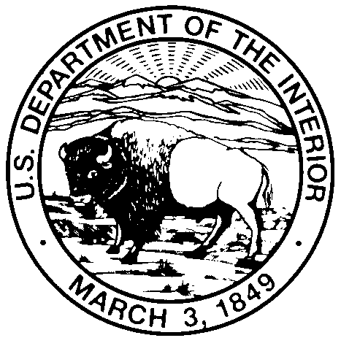

Indian Arts and Crafts Board
Washington, D.C. 20240

Indian Arts and Crafts Board (IACB) – Juried Youth Art Competition and Exhibition

Open to Enrolled Members of Federally Recognized Tribes Ages 12 - 18

The competition features the theme “We are Still Here.”

Competitions and Exhibitions will be held at the following locations:

Sioux Indian Museum, 222 New York St., Rapid City, South Dakota
Southern Plains Indian Museum, 801 E Central Blvd., Anadarko, Oklahoma

Official Rules

The Following Documents are Required

- Official written documentation verifying the youth’s tribal enrollment in a Federally recognized tribe
- Completed and signed Youth Art Competition and Exhibition Photography Release Form
- Completed and signed Youth Art Competition and Exhibition Entry Form
Artwork Accepted

- Any two dimensional original artwork
- Maximum size of 24” X 36”
- Submission deadline April 7, 2017
Handling of Art Work

- It is the responsibility of participant to deliver or ship their artwork directly to the participating museum of their choice
- The IACB encourages participants to pick up their artwork directly from the participating museum at the conclusion of the exhibit
- If local pickup is not possible, the IACB will cover the cost of return shipping of the artwork
- A selection of submitted artwork will be hung by the IACB in an exhibition to honor competition participants
- IACB insurance will cover the artwork during transport to and from, as well as during display, and/or while in the possession of the Sioux Indian Museum and the Southern Plains Indian Museum

Continued on other side

Awards

- Artwork will be judged by an independent panel of jurors
- Artists receiving first, second, and third place awards will receive $250, $150, and $100 respectively
- Financial awards must be made through electronic bank transfer. Winners must complete a direct deposit form in order to receive awards
- Winners will be announced on April 21, 2017
Exhibitions of selected artwork will be displayed at the participating IACB museums from April 21 through May 26, 2017.

FOR MORE INFORMATION CONTACT Conor McMahon, Chief Curator, at 605-394-2381 or sim@ios.doi.gov

Notice: IACB employees and their immediate family members are NOT eligible to participate in the IACB Juried Youth Art Competition and Exhibition.

United States Department of the Interior

Indian Arts and Crafts Board
Washington, D.C. 20240

Youth Art Competition and Exhibition Entry Form

Notice: The following information must be provided in order for your child’s artwork to be eligible for inclusion in Indian Arts and Crafts Board exhibitions, promotional publications, educational materials, and website.

Artwork

_______________________________________ ________________________
Title Date Created

_______________________________________ ________________________
Medium Dimensions

_______________________________________
Insurance Value

Contact Information

________________________________ ____________________________________
Artist/Child’s Name Parent or Legal Guardian’s Name

________________________________ ____________________________________
Artist/Child’s Signature Parent or Legal Guardian’s Signature

________________________________ ____________________________________
Artist/Child’s Age Address

____________________________________
City State Zip

____________________________________
Phone number

____________________________________
Email address

United States Department of the Interior

Indian Arts and Crafts Board
Washington, D.C. 20240

Youth Art Competition and Exhibition Photography Release Form

Notice: The following information must be provided in order for photographs of your child’s artwork to be eligible for inclusion in Indian Arts and Crafts Board exhibitions, promotional publications, educational materials, and website.

I hereby give permission to the Indian Arts and Crafts Board (1) to photograph my child’s, _____________________________, artwork loaned to the Indian Arts and Crafts Board; (2) to distribute photographs of my child’s artwork for the purpose of publicizing an exhibition of his/her works; and (3) to reproduce any art works as illustrations in informational and promotional publications, including on the IACB website.

______________________________________
Parent or Legal Guardian’s Name

_______________________________________
Parent or Legal Guardian’s Signature

_______________________________________
Date

_______________________________________
Address

_______________________________________
City State Zip

Please mail the completed form along with the artwork to:

Conor McMahon
Sioux Indian Museum
222 New York St.
Rapid City, SD 57701

In compliance with the Privacy Act of 1974, the authority for requesting information is contained in the Indian Arts and Crafts Act of 1990 and Department of the Interior Indian Arts and Crafts Board regulations at 25 CFR Chapter 7A. The principal purpose for collecting information is to promote the artwork of members of Federally recognized tribes. The requested information will be used by agency officials to determine eligibility, communicate with participants and process entries submitted for art competitions or museum displays, and to award prizes to contestants. Information may be disclosed to agency officials to facilitate promotional activities and process awards, or to appropriate regulatory or law enforcement organizations as required by law. Providing the information is voluntary, however, not providing the requested information may affect eligibility to participate in art competitions or to display artwork in museums.

