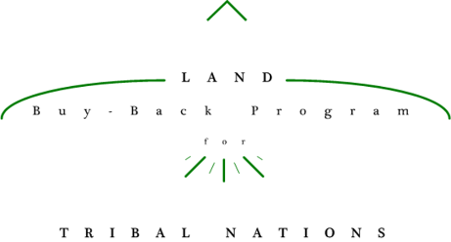**<Reservation Name> Land Buy-Back Offer**

Must receive Tribal approval to use crest/seal. If not approved use Buy-Back logo.

<Insert Tribal Seal/Crest>

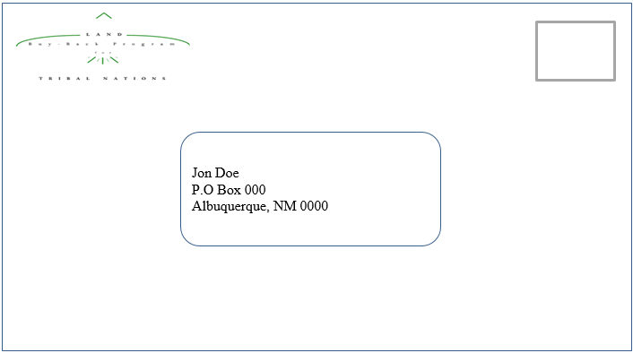

**Questions?**

If you have questions about the program or your offer please visit <our/the Program’s> website at

<Insert Tribal Buy-Back website or www.doi.gov/buybackprogram>

You can also <visit our office, call us, or email us> at:

<Tribal Office Address>

<Tribal Office Phone Number>

<Tribal Email Address>

. You can update your account information by calling the Trust Beneficiary Call Center at 1.888.678.6836

**Time Sensitive Materials-OPEN IMMEDIATELY**

**Follow Enclosed Instructions**

**If you received this offer and want to participate in the Land Buy-Back Program please be sure to SEND YOUR OFFER BACK by <Date to send back>.**